Team 517 Operation Manual
Alanna Black, Jayson Dickinson, Christina Morrow, Ryker Mullinix
FAMU-FSU College of Engineering

Overview
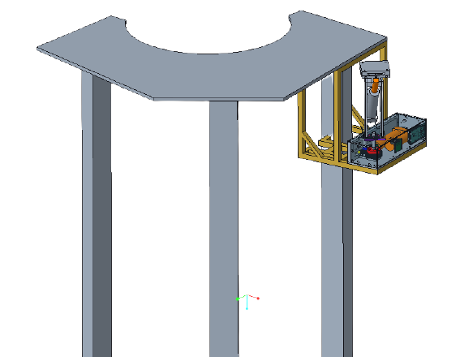
Figure 1: ARROW Orientation
Acronyms
ARROW – Automated and Ranged Relocation of the LSMS for Wider application
CAD – Computer Aided Design
CLPS – Commercial Landing Payload Services
DC – Direct Current
EVA - Extra-Vehicular Activity
LSMS – Lightweight Surface Manipulation System
LED – Light Emitting Diode
NASA - National Aeronautics and Space Administration
RGB – Red Green Blue
Project Description
NASA, partnered with CLPS, has developed an autonomous means of payload transportation to operate on the lunar surface, called the LSMS. This project is concerned with offloading the LSMS from the CLPS lander, so that it may be used for a wider range of tasks. This is necessary for establishing a lunar presence and building the foundation for future missions to Mars. NASA wants to create a means of building a base at one of the poles on the Moon and develop a method of rapid assembly of the base. In order to do this, the LSMS must be relocated onto a mobile platform. This will be done with a design called the ARROW.
Project Objective
The objective of this project is to offload the LSMS from the CLPS lander onto a platform on the lunar surface.
Key Goals
A key goal is to design the ARROW to be capable of off-loading the LSMS. Making this a key goal is a direct result of the customer statement regarding the project requirements.
Another key goal of this project is to design the ARROW to be scalable for any size LSMS. In the virtual simulation there should be a 1:1 lifting capability to weight ratio for the ARROW relative to each LSMS size. There should be the ability to create ARROWs of various sizes so that money can be saved in the creation of smaller models and a prototype can be delivered to the customer that works exactly as the final product would work. This allows for potential issues to be addressed prior to the creation of the final product assembly.
The final key goal is for the ARROW to be completely autonomous with human control being activated fail-safes. The machine or mechanism would operate without any human intervention needed. Keeping the ARROW completely autonomous also means it must be able to communicate with other devices on the lander if the design is not completely mechanical.
Assumptions
Some assumptions were made to narrow the scope of the teams’ efforts. It is assumed that the team is not responsible for transportation of the ARROW to the lunar surface and operation of the ARROW will take place on the moon. It is also assumed that the ARROW will be stationary, with access to power from the CLPS lander. Another assumption is that reusability of the ARROW is not a concern. Additionally, it is assumed that the LSMS will send a ready signal to the ARROW and the duties of the ARROW will occur as part of the automated landing sequence. It is also assumed that an existing end effector will be utilized, to increase time spent on other design aspects. The LSMS and ARROW locations on the lander are at the discretion of the design team and the LSMS can dock to the lunar platform. Environmental factors such as regolith and temperature changes are also assumed to not be a concern for this project design. It was also assumed that in-space and in-space EVA assembly will not be required. For the demonstration it was also assumed that the weight of the miniature LSMS is 25% of its lifting capability at the wrist.
Component/Module description
Cad Overview
This section includes CAD information of the ARROW and the demonstration components. The following CAD models are of the fully assembled design of the ARROW.
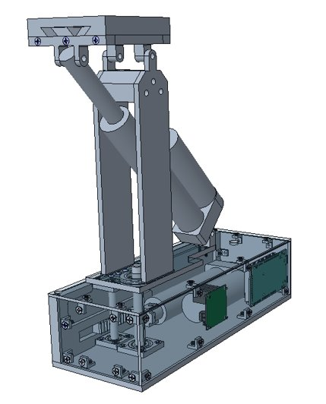
Figure 2: Front View of the ARROW

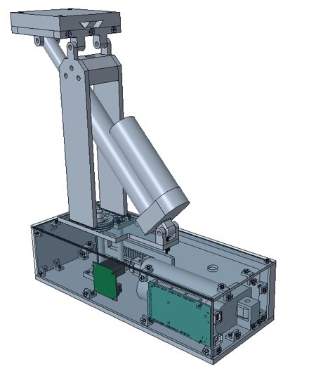
Figure 3: Rear View of the ARROW
The model below is the full exploded view of the ARROW.

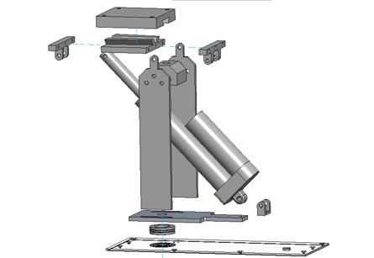
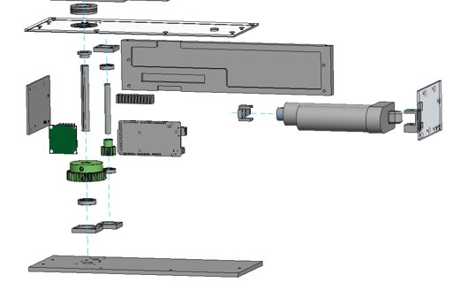
Figure 4: Exploded View of the Full Assembly
The following CAD shows the assembled model of the planar rotation system of the offloader. This includes one of the linear actuators, the rack and pinion, the gear, and the thrust bearing.
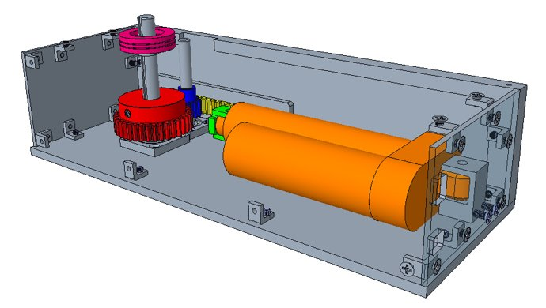
Figure 5: Lower Module Detail View
The zoomed in top-view of the rack and pinion assembly is shown below.
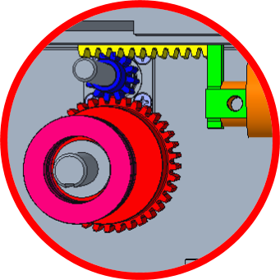
Figure 6: Top View of the Rack and Pinion Assembly
Drawings of this CAD model are shown in Appendix A.
Modules
The following modules include parts of the ARROW that are utilized in the demonstration of the offloading system. The electrical module includes the wiring information, electrical components used, and a connection diagram. The vertical rotation module includes the rack and pinion system, gearing, and one of the linear actuators. The horizontal rotation module includes information about the other linear actuator and the connector plate. The demonstration module disseminates information regarding the components that are separate from the ARROW but are necessary to the demonstration of the final product.
Electrical Module
The electrical module consists of the following parts: two RGB LEDs, one dual H-bridge DC motor driver, one Arduino MEGA 2560 microcontroller, and one 9V DC power supply. A wiring diagram containing these components is shown next.
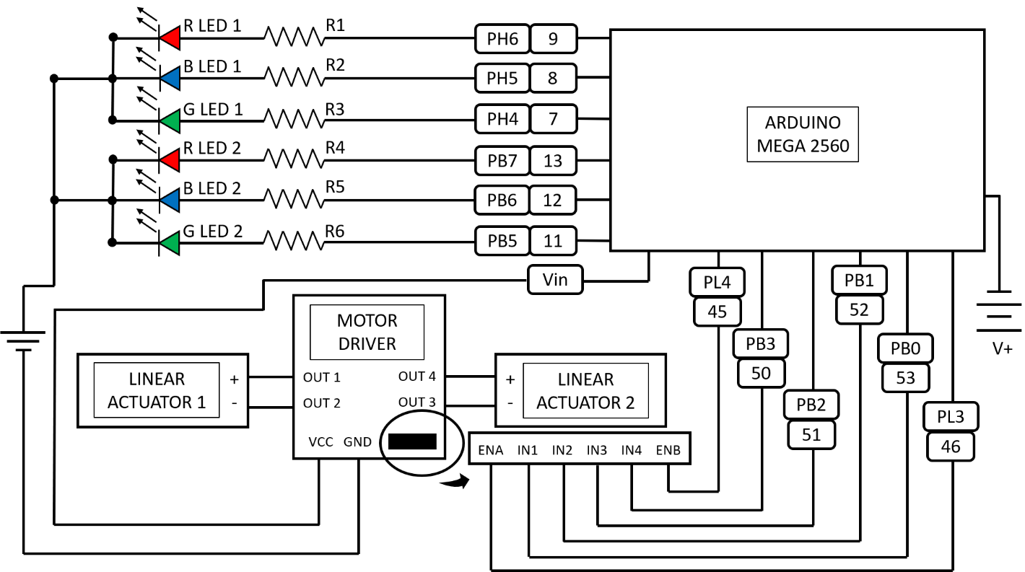
Figure 7: Wiring Diagram
This wiring diagram shows how the various component connect. In the diagram V+ is used to represent the 9V DC power supply plugged into an electrical outlet.
Vertical Rotation Module
This module controls rotation about the vertical axis using a linear actuator in conjunction with a rack and pinion gear system. The rack and pinion system is used to convert the linear motion of the actuator to rotational motion. The gears also allow for the force transmitted by the linear actuator to be increased threefold. The additional gearing is required for the system to output the required torque. This system is used to rotate the turntable mount plate. The motion of this module allows the LSMS to be rotated the required 90 degrees.
Horizontal Rotation module
This module controls rotation about the horizontal axis using a linear actuator in conjunction with the LSMS connector plate. The horizontal rotation module is mounted on top of the turntable mount plate, tower side plates are used to secure the system to this plate. The linear actuator for this system is at angle to allow the system to rotate down 44 degrees while still minimizing the device height.
Demonstration Module
This module contains components that are used to demonstrate the ARROWs functionality.
LSMS model
The LSMS model consists of three sections: the kingpost, shoulder, and forearm. The model simulates the weight distribution of the miniature LSMS on the moon. The next figure depicts the crane model.
Figure 8: LSMS model
Payload Deck model
The payload deck model is used to simulate the height and shape of the payload landing deck on the peregrine lander. The model of the payload deck is shown next.
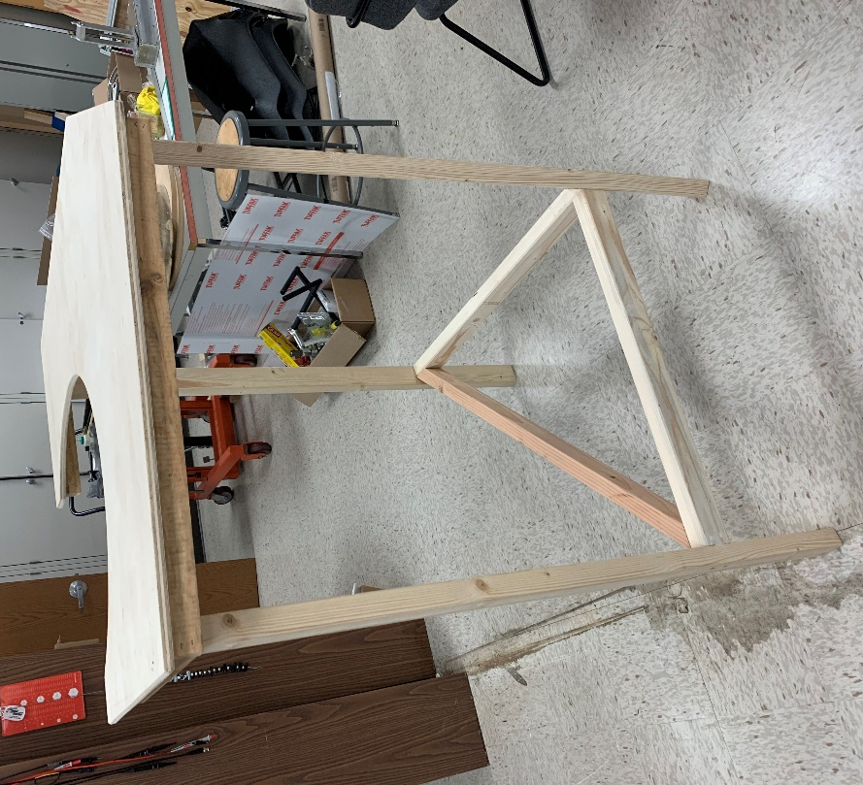
Figure 9: Peregrine Payload Deck Model

Cradle
The cradle is a bracket used in the demonstration to mount the ARROW to the payload deck model. It is necessary for simulating a properly mounted ARROW that is ready for use. The cradle is composed of T-slot aluminum profiles. See next figure.
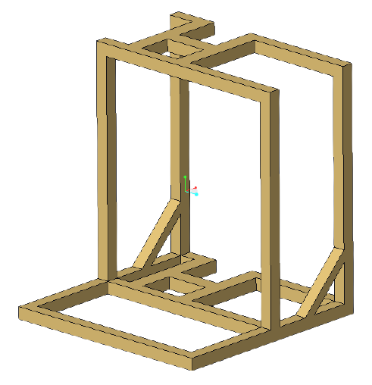
Figure 10: Cradle Design
Automation Code
The following information describes the code that is used to automate the LSMS offloading system. This code can be seen in appendix B.
State Diagram
Shown next is the state diagram of the ARROW automation code, which details each state or stage of the automation process. The ARROW starts in the off and idle state 0. When the LSMS is connected to power via the wrist, this triggers the transition to state 1 where the LSMS is powered and sending the “ready” signal to the ARROW. Once the ARROW receives the ready signal, this triggers the transition to state 2, where the first linear actuator will be activated, and the ARROW will spin the LSMS 90 degrees about the vertical axis. Spinning the LSMS has been defined as Stage 1. Once Stage 1 is complete, this triggers the system to move to state 3, which houses Stage 2: lowering the LSMS. The second linear actuator is activated, pivoting the connector plate 44 degrees towards the ground. Once Stage 2 is complete, the ARROW will revert to the off and idle state 0. At any given point, if the power connection between the LSMS and the ARROW is severed, the ARROW will revert to the off and idle state 0.
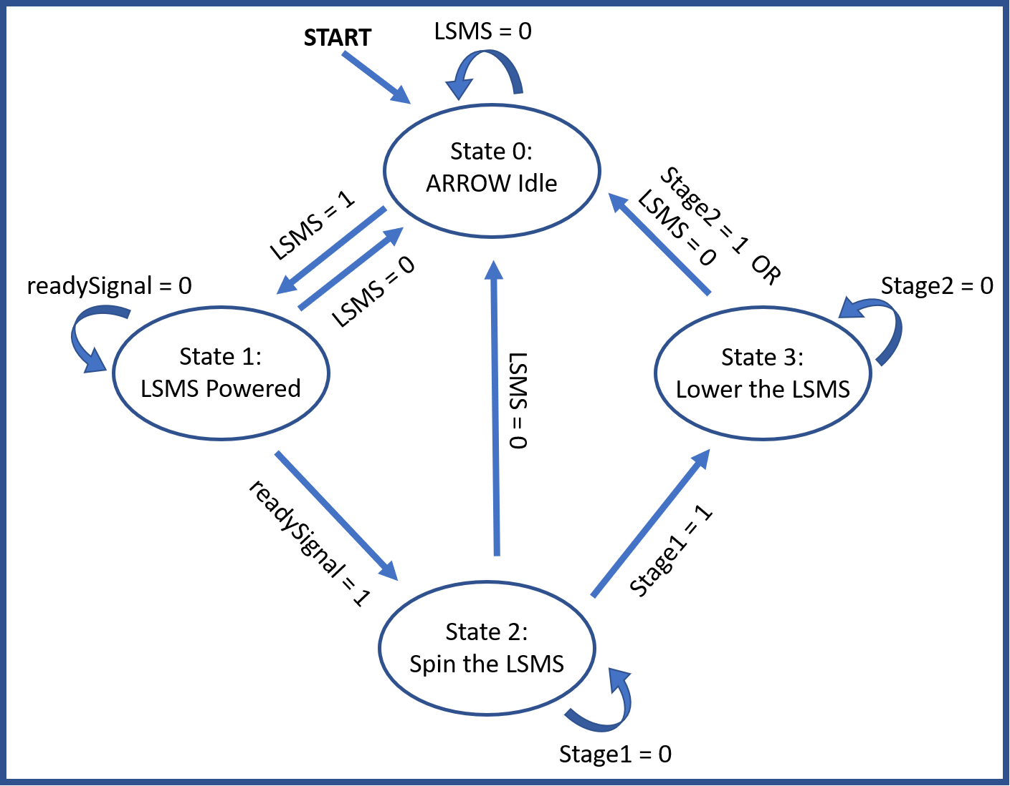
Figure 11: State Diagram
Integration
Assembly
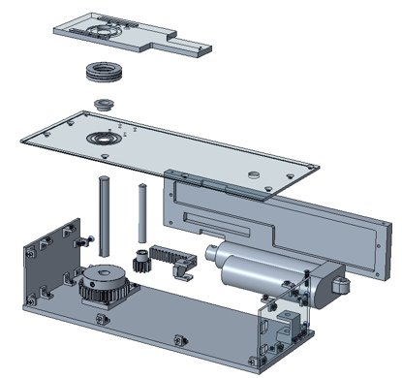
Figure 12: Lower Module Assembly
For assembling the lower module of the ARROW, 8-32 screws will be used for every bracket. This includes the 16 L-brackets, attaching the lid to the side walls, the bearing brackets to the bottom plate and the lid, and the mounting bracket for the bottom linear actuator.
Affixing the Arduino and motor driver to the front panel will use 8 4-40 screws and 2 more will be used to attach the rack connector plate to the rack itself.
To attach the upper linear actuator mount to the turntable plate as well as the tower to the plate, 8 6-32 screws are utilized.
The 6 screws used to bolt the tower together are size ¼-20.
The torque specs for each screw are in Table 1, shown below. Each screw should have a dab of Loc-Tite applied to in to ensure the screws do not back-out during transport or use.
Table 1: Torque Specs
Screw | Max Tightening Torque [ft-lbs]
4-40 | 2.9
6-32 | 5.3
8-32 | 10.8
¼-20 | 45.6

Operation
The cradle will be attached to the corner of the payload deck on the side that is 28 inches or 0.71 meters. It will be at the far edge of it so that the ARROW can be 0.95 meters from the LSMS when the crane is attached. The ARROW will have the front panel with the Arduino away from the payload deck as this allows the proper rotation direction. The port for feeding power from the lander to the ARROW will be free to have a cable run along the cradle into the ARROW. The top of the connection plate, once the ARROW is attached to the cradle, should be near the corner of the deck and they should be level with each other. See Figure 1 for what the final result should look like.
When the lander has touched down on the lunar surface, the LSMS will offload the payloads. Once this process is complete, the LSMS will attach to the connection plate of the ARROW. The dovetail connection will support the crane as it is rotated 90 degrees off the lander and then lowered to the Chariot mobility chassis.

Troubleshooting
If there are issues running the full offloading operation, there are a few aspects to check for that may be causing the problem. First, it would be a good idea to check the wiring connections between the Arduino, the linear actuators, the motor driver, and the power supply. You can double check that the wiring is properly arranged by referring to the wiring diagram shown in the Component/Module section. Another troubleshooting problem may involve automation errors, which you can check to see by debugging the code or redownloading the code found in the Component/Module section. When using the ARROW for the first time, select “no” when prompted to reset the arrow. This will allow for verification that the ARROW has been set up properly and there are no snags in the wiring, stuck bearings, loose screws, etc. Another possible issue would be any obstructions in the way of the linear actuators being able to rotate and offload the LSMS, in which the surrounding area of the demonstration should be cleared.

Appendix A-Drawings
The following images are drawing that were taken to the FAMU-FSU COE machine shop.
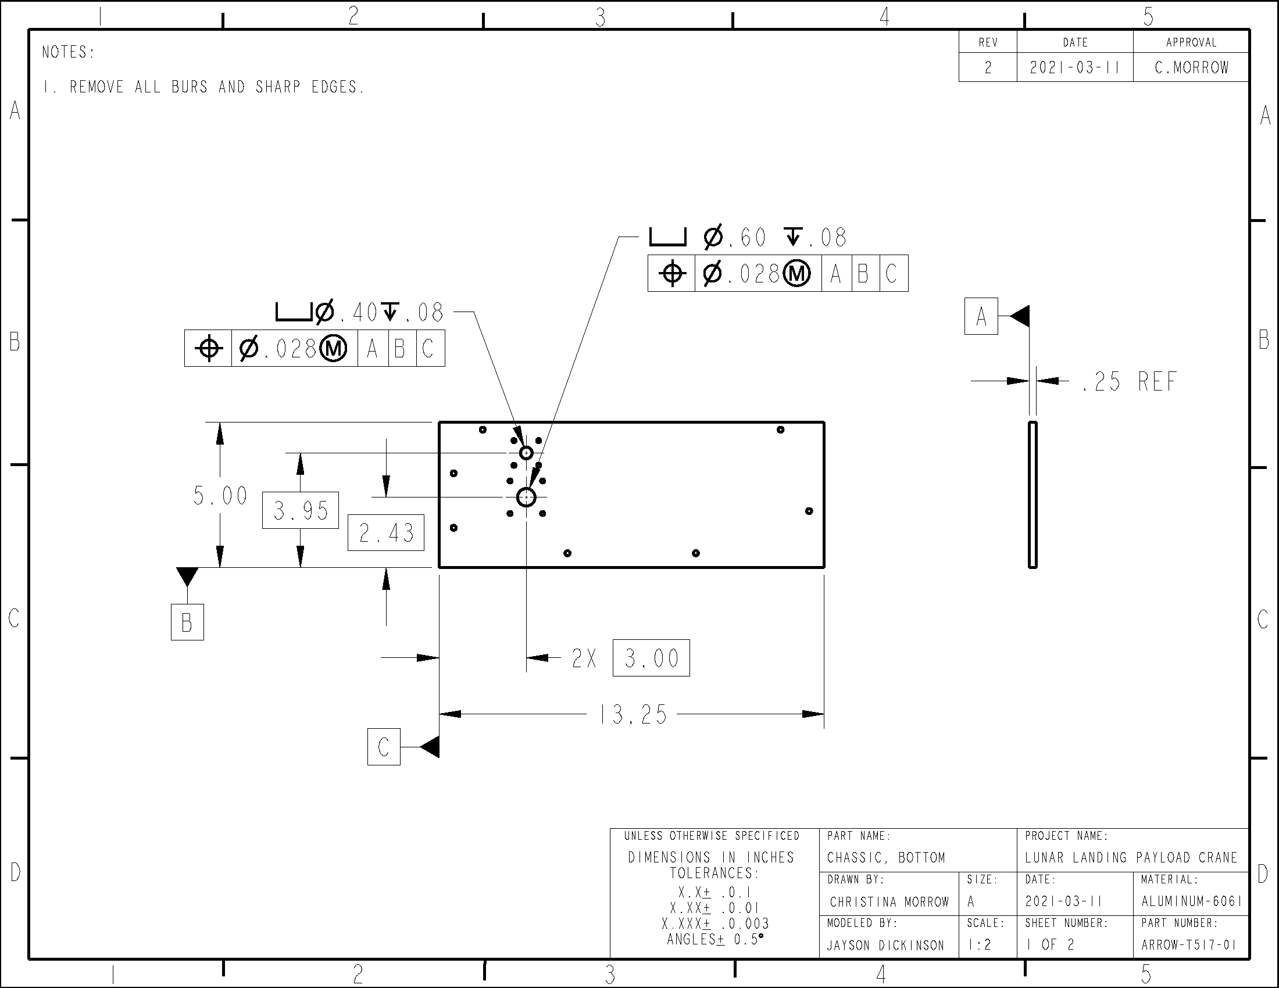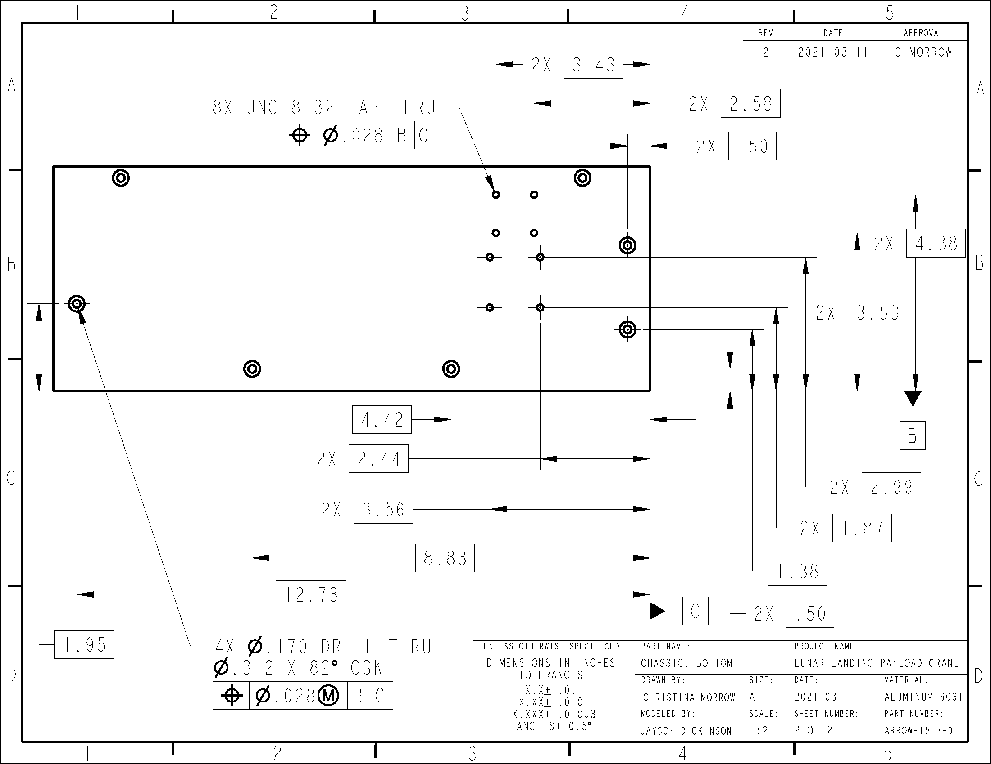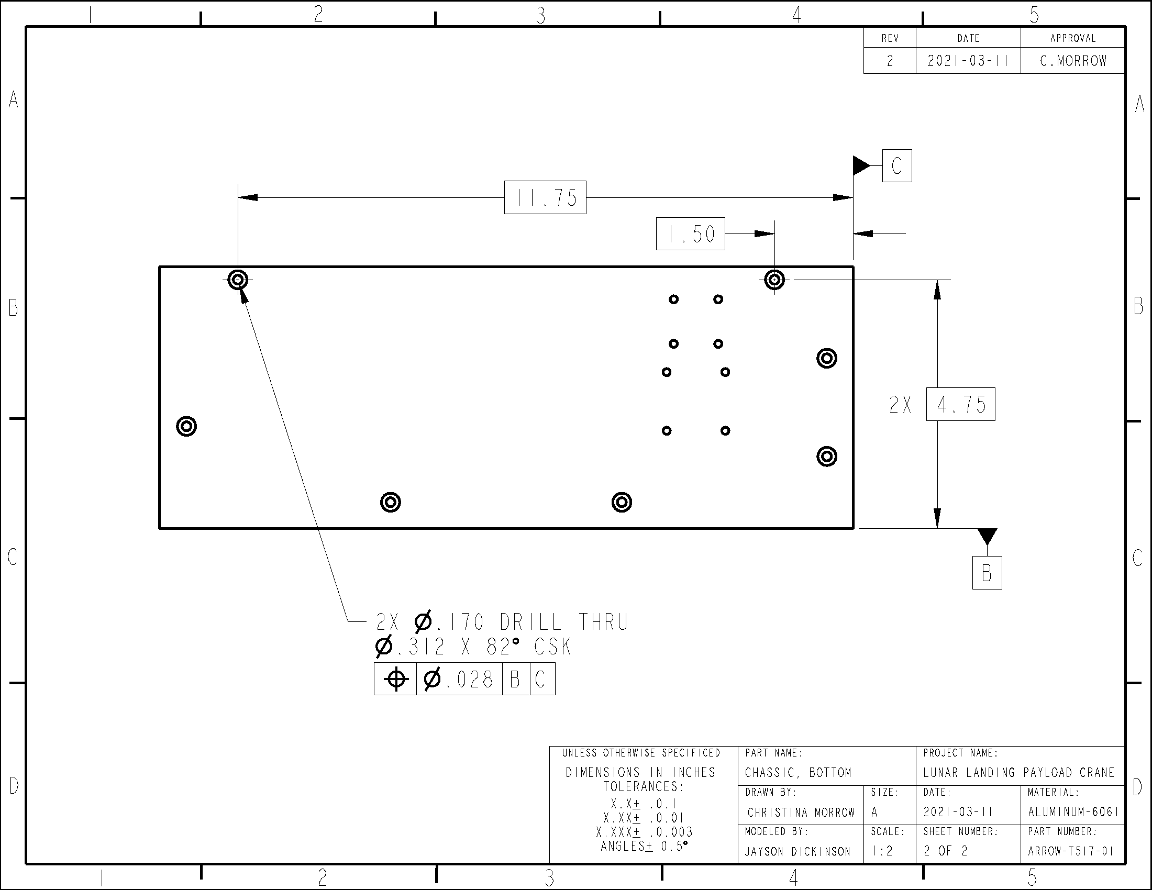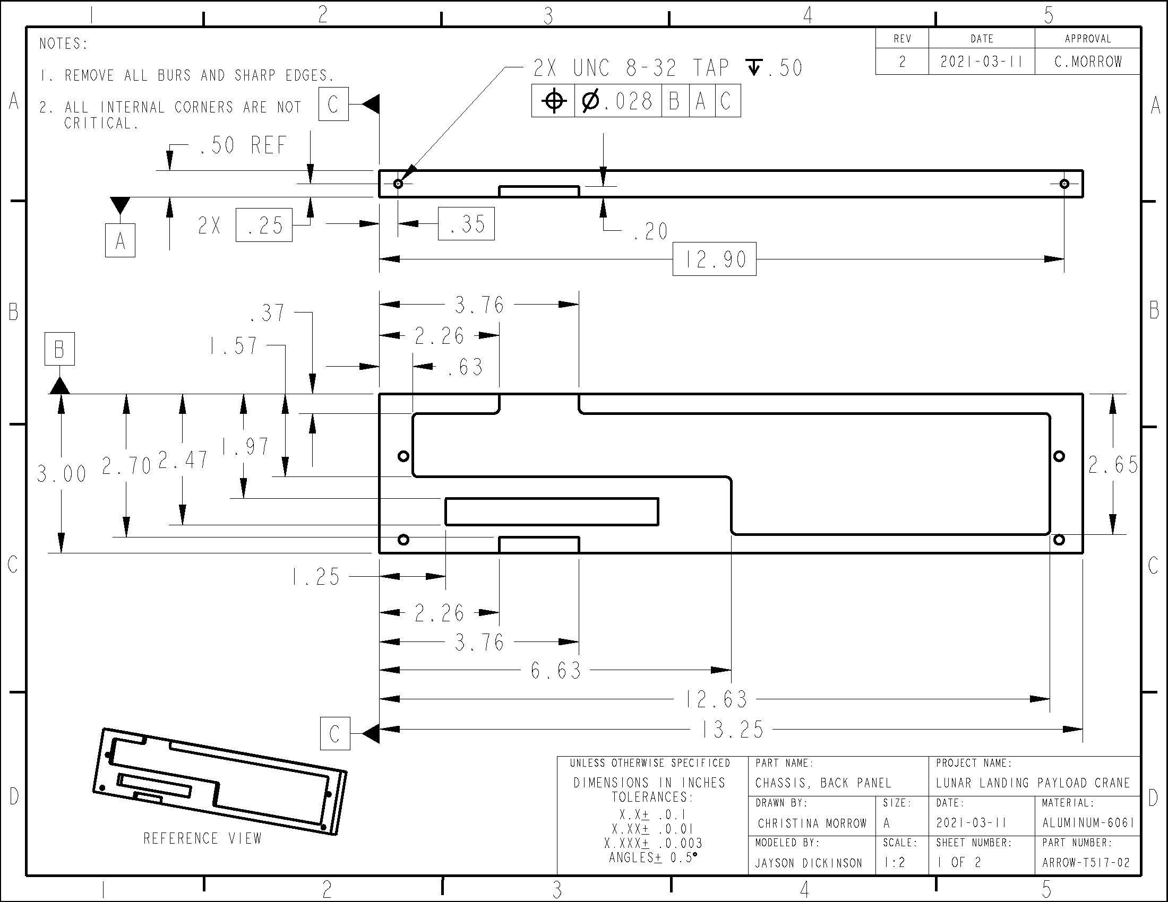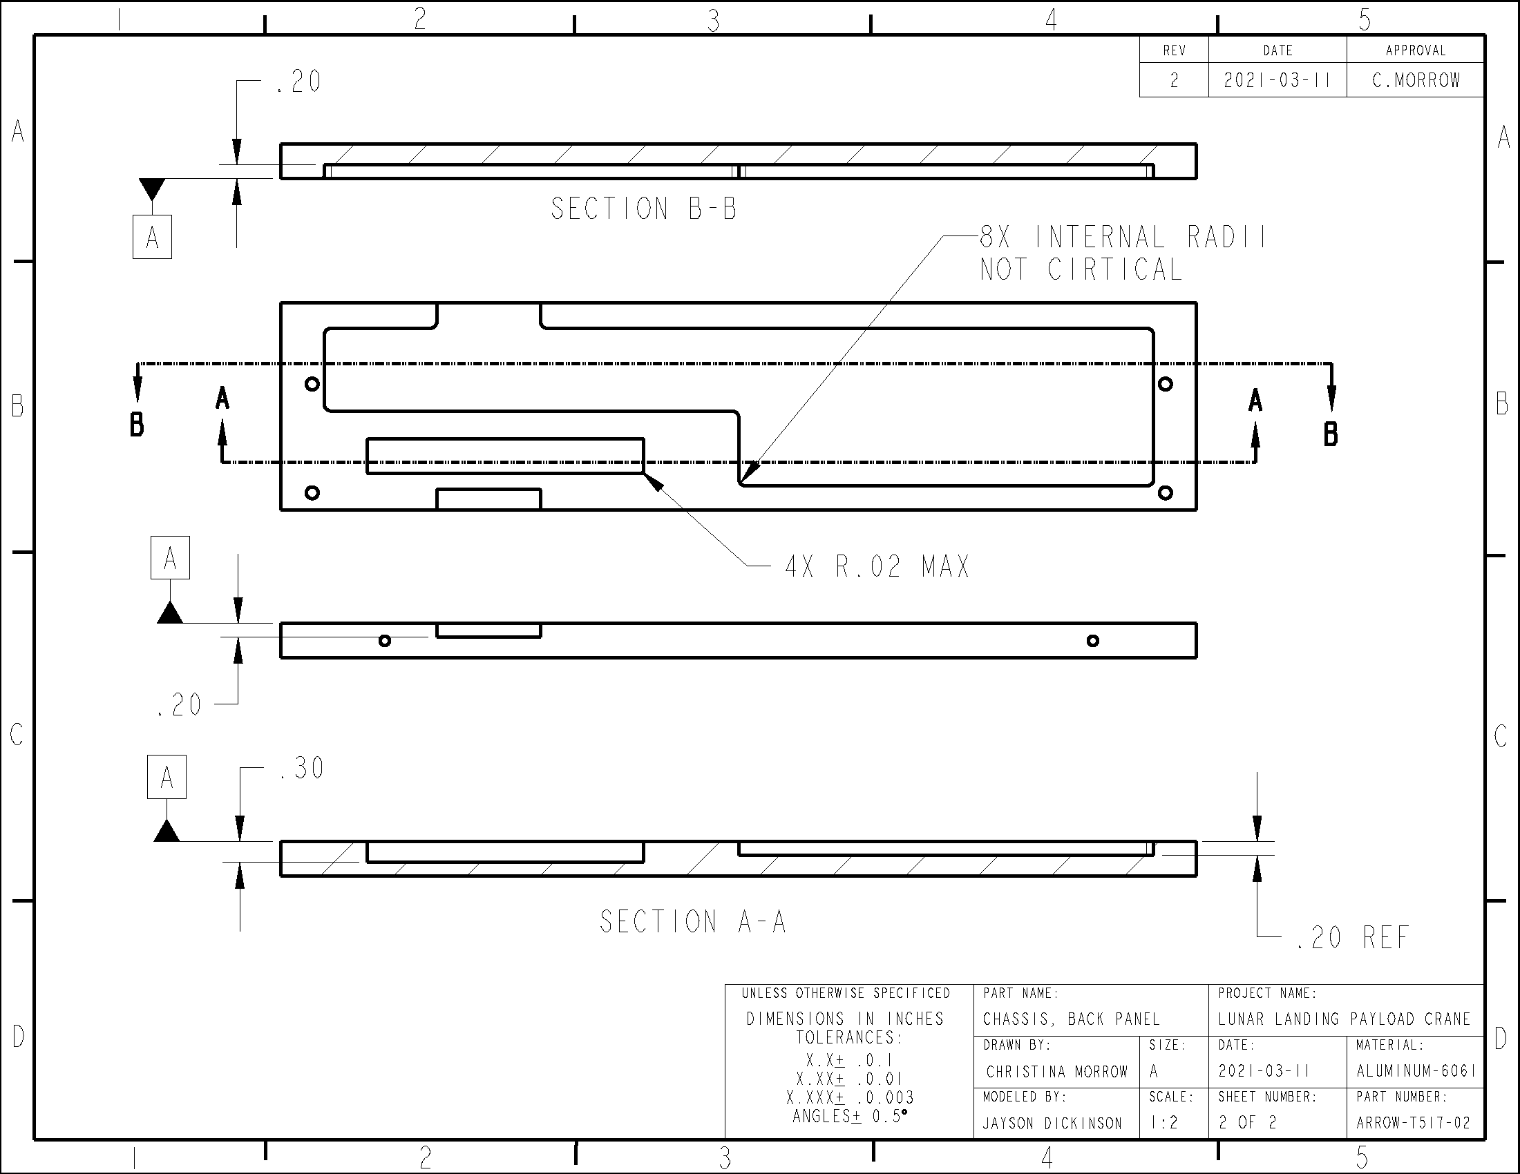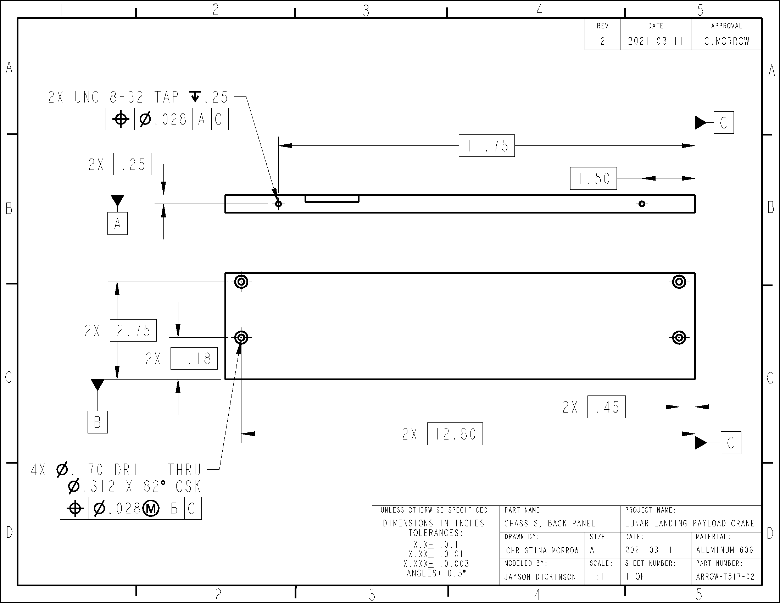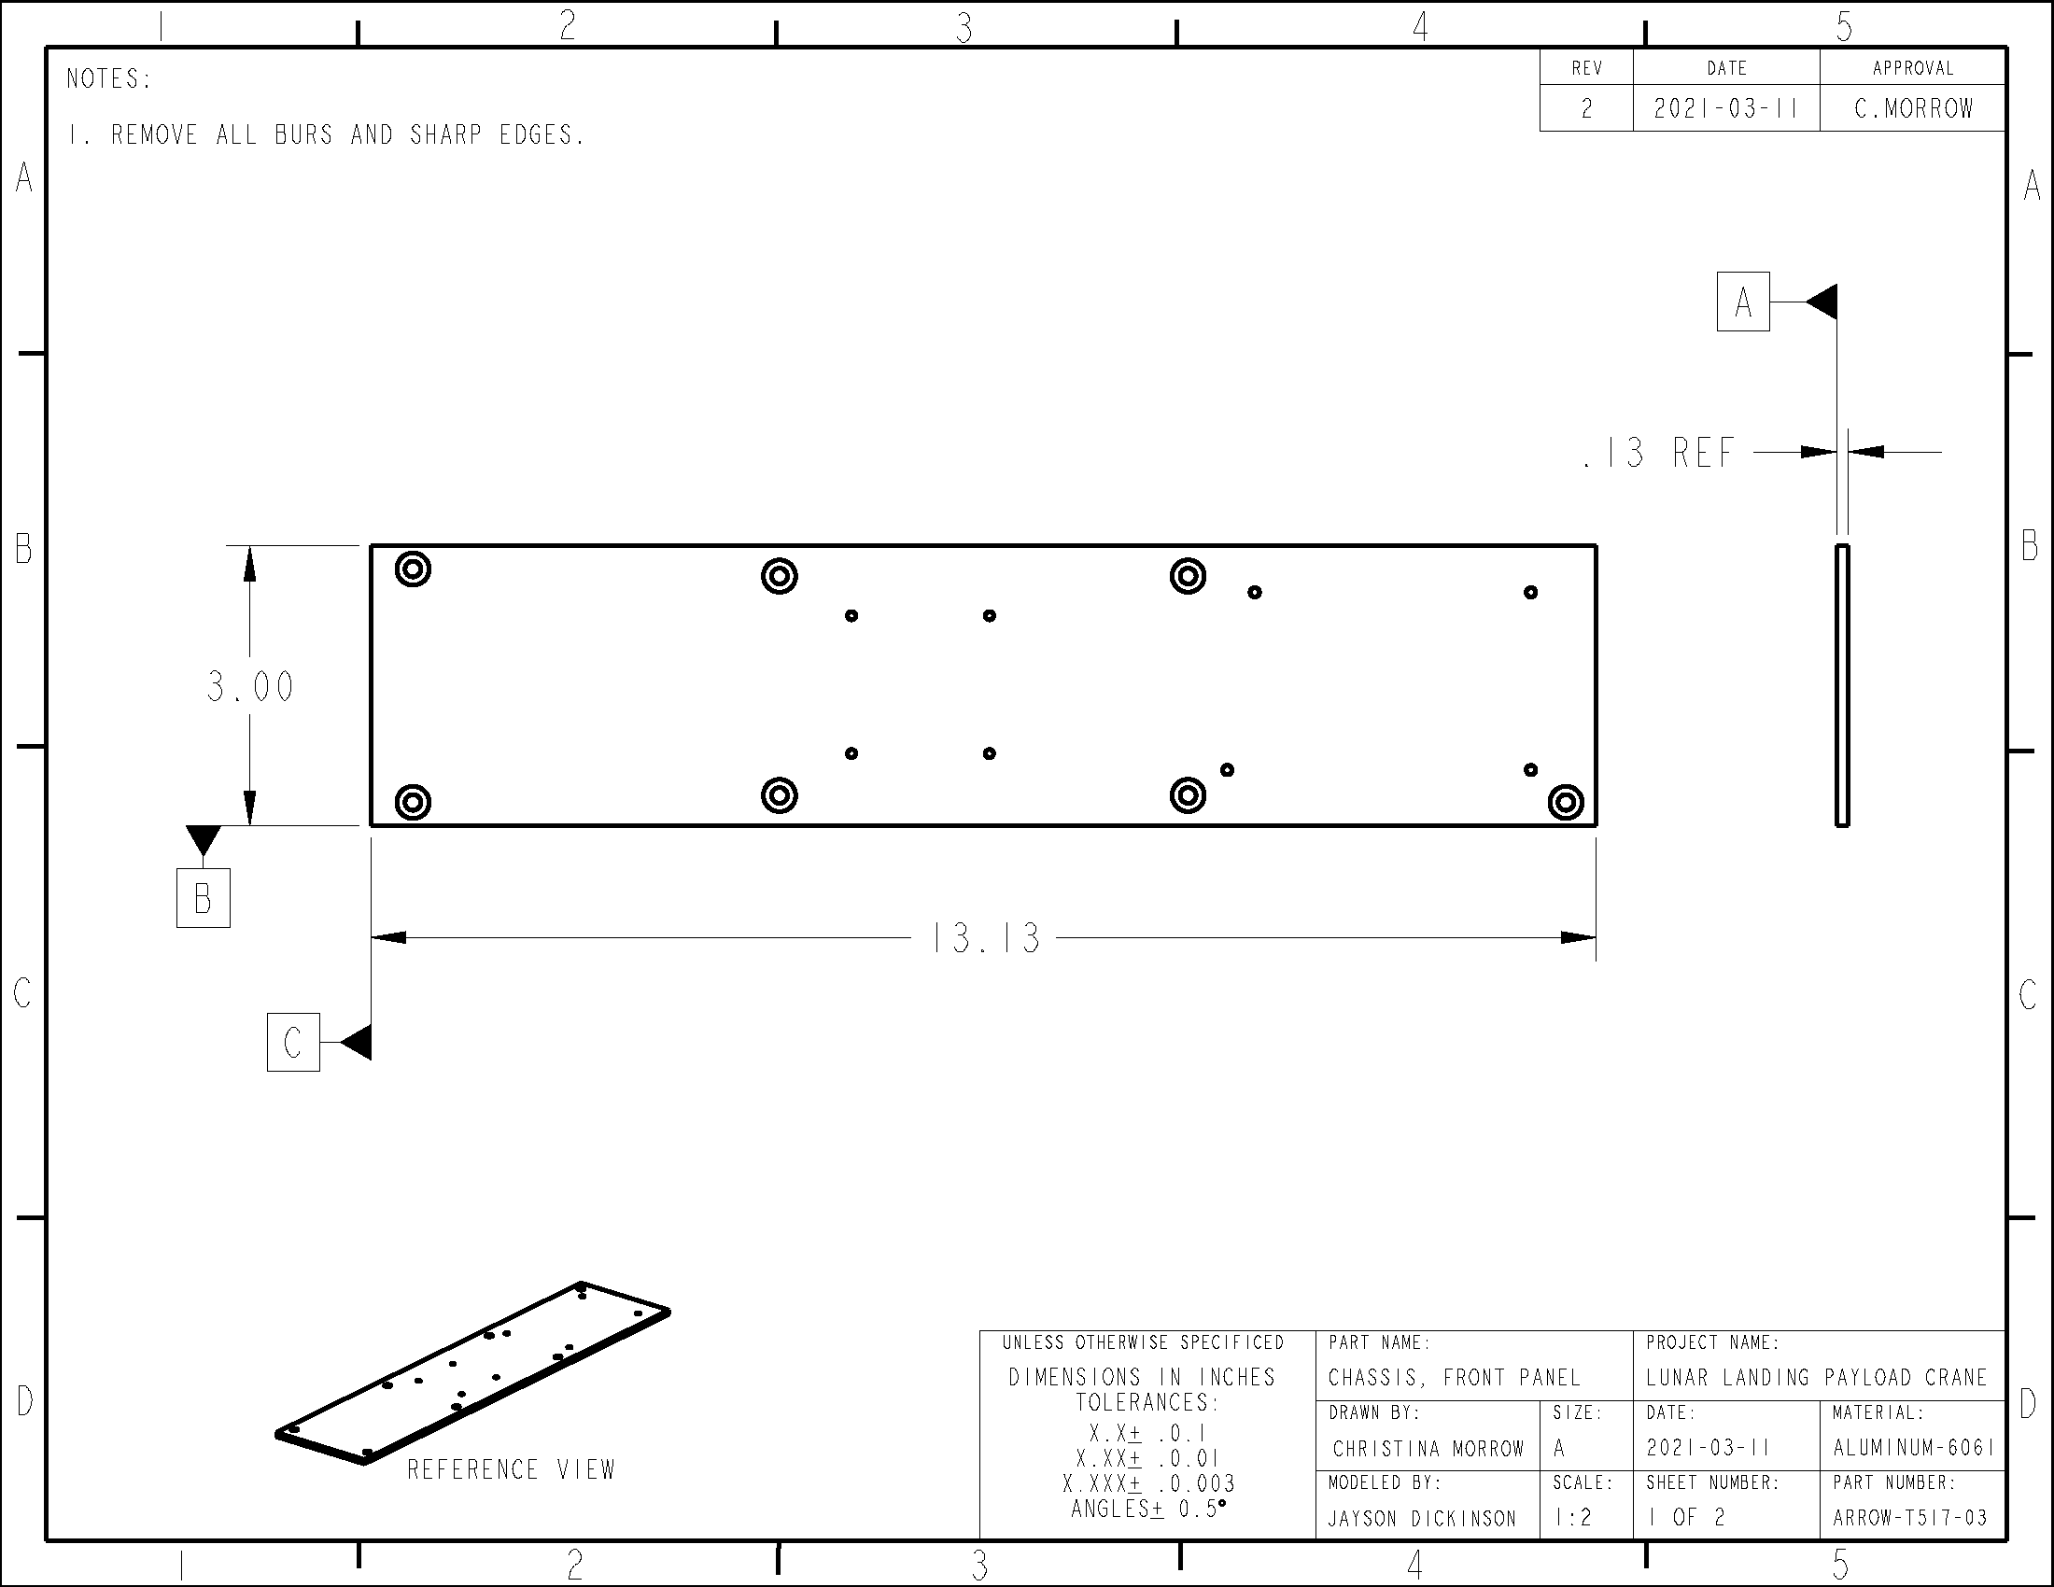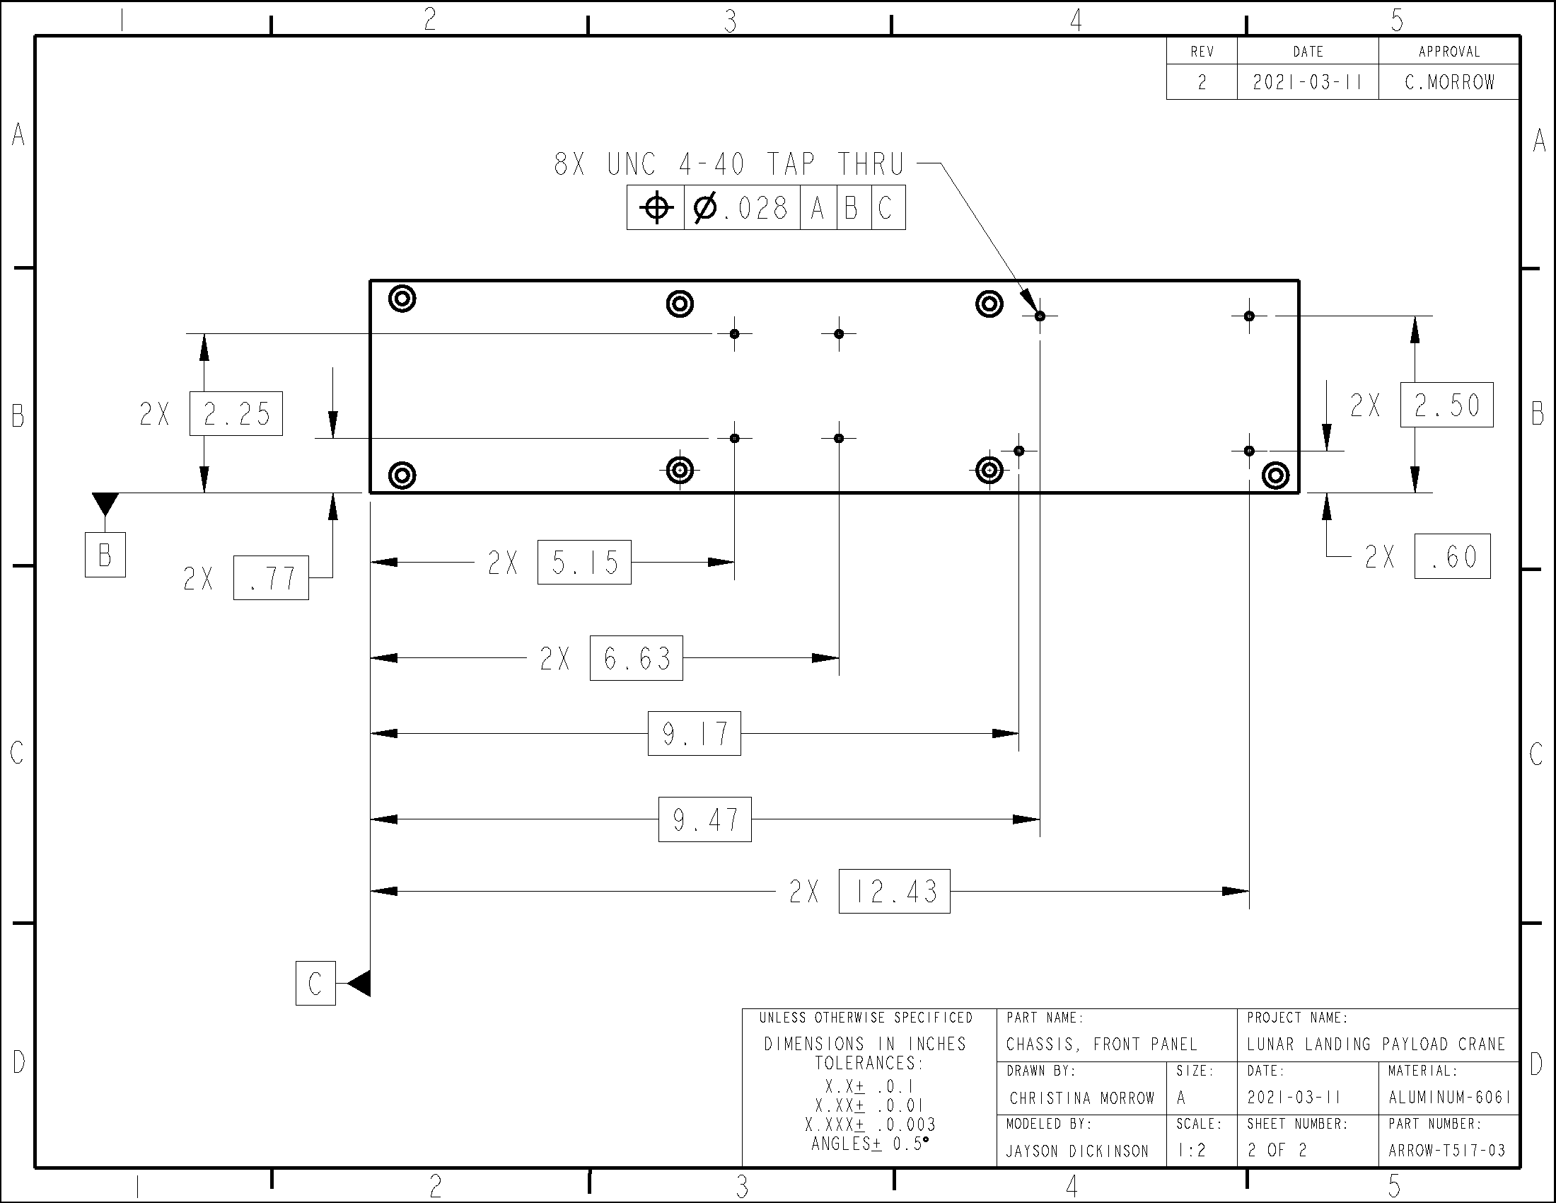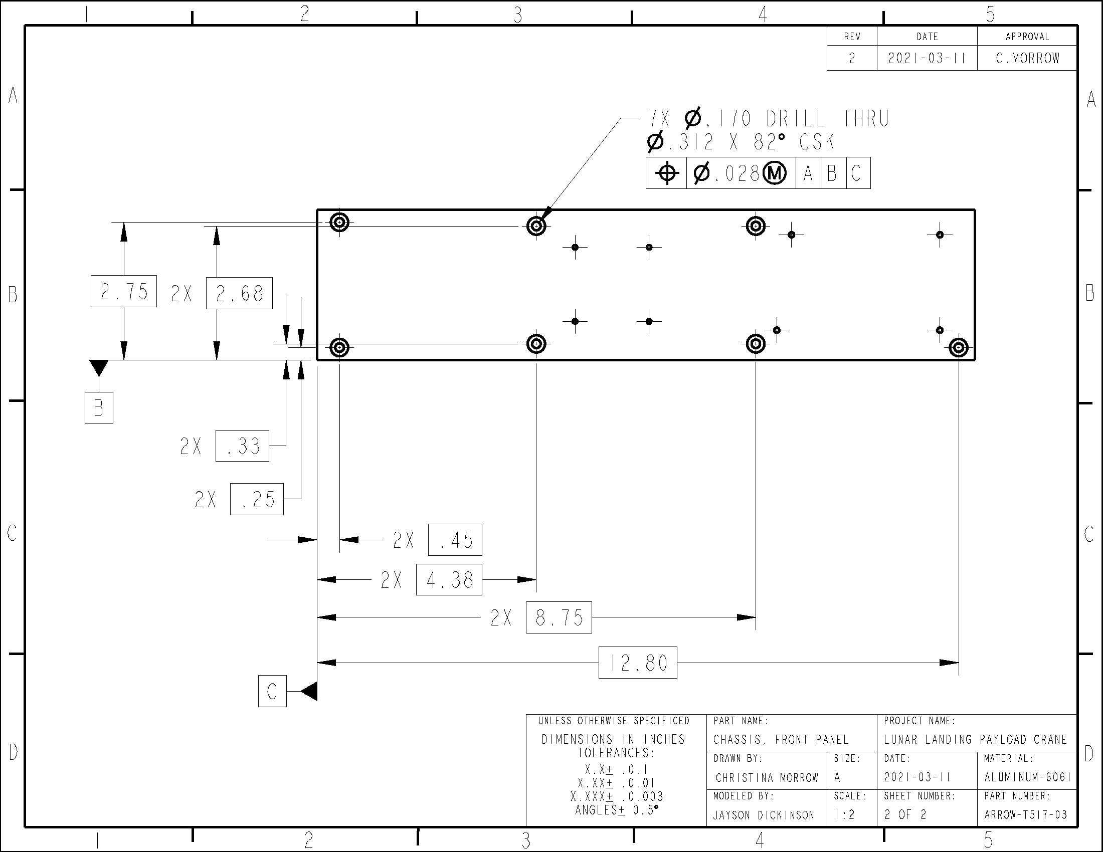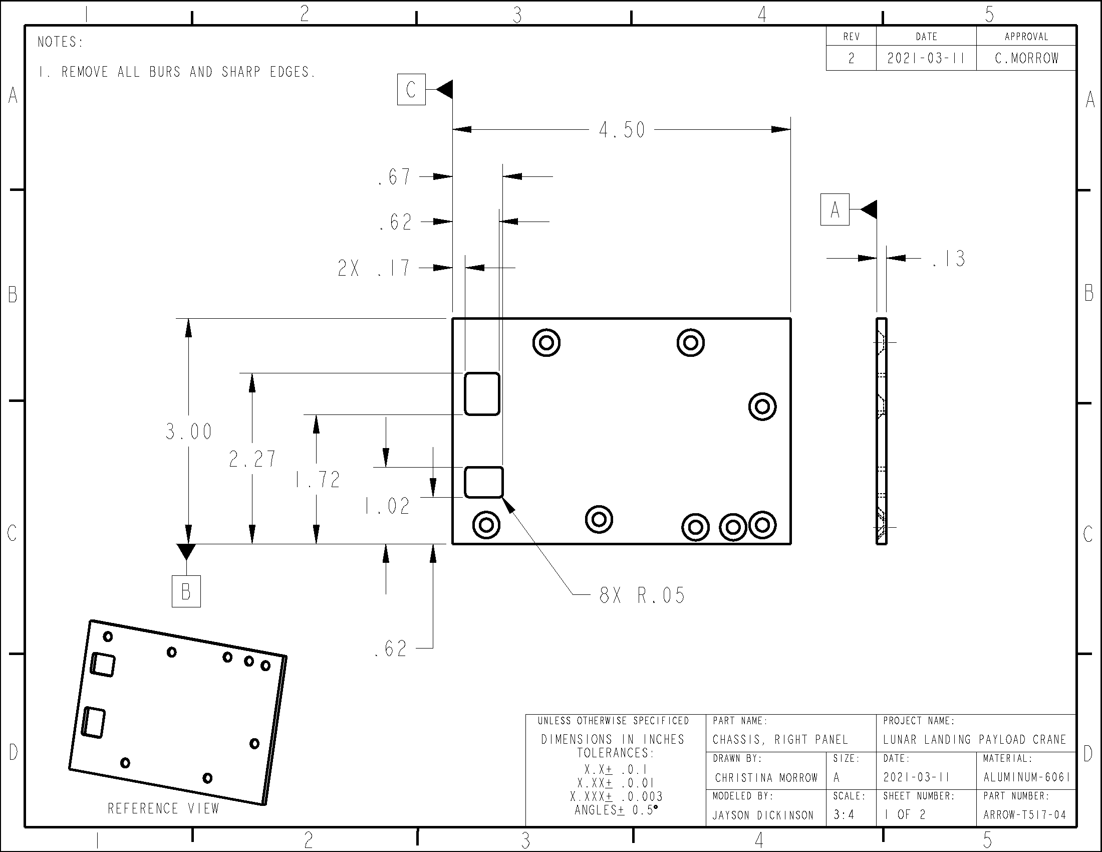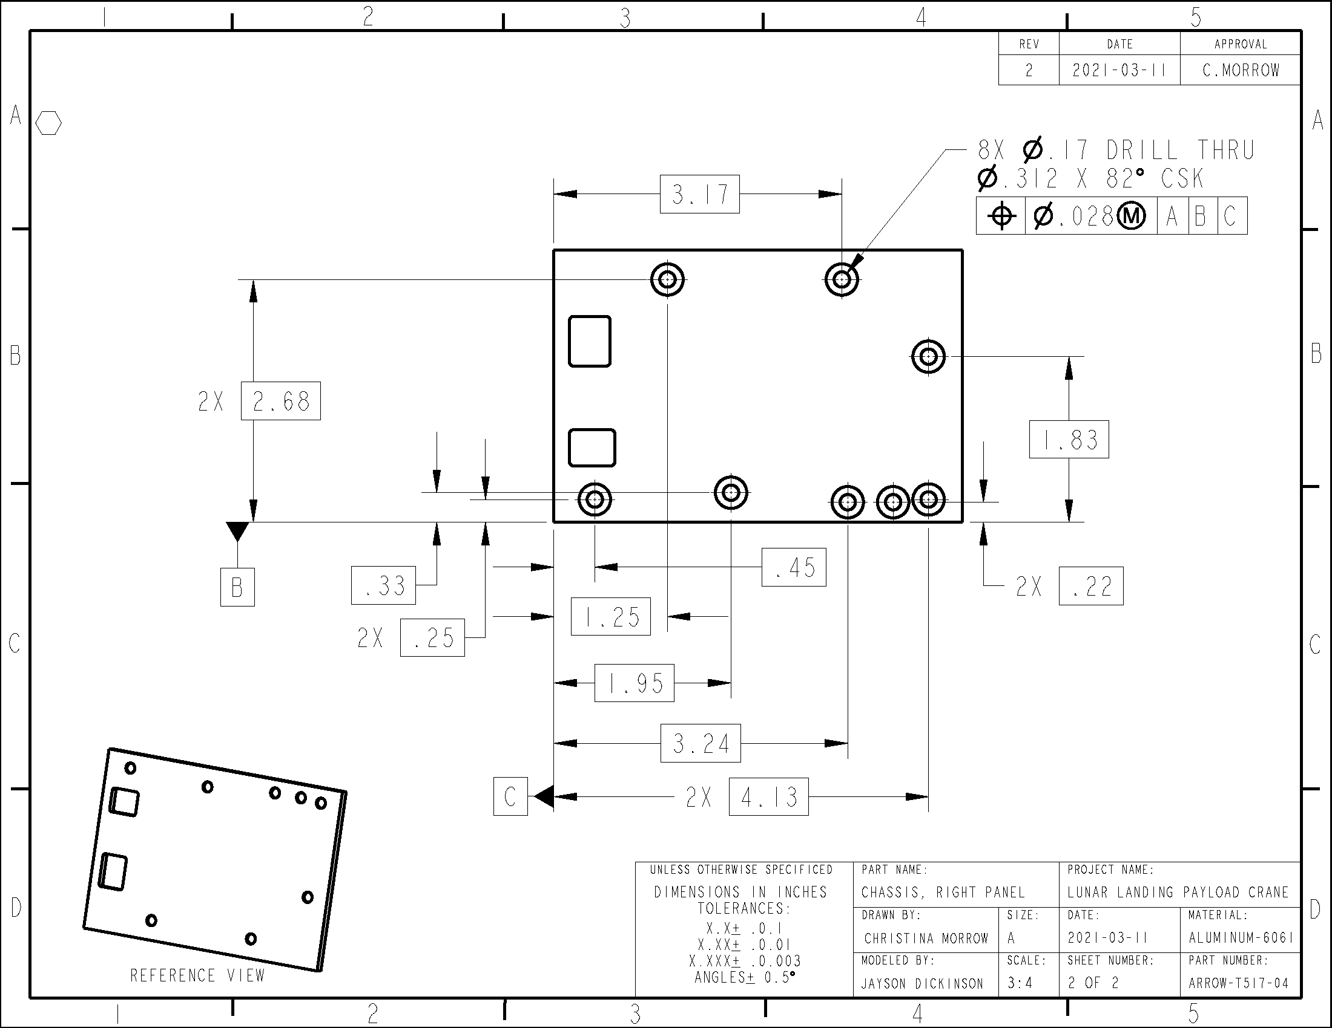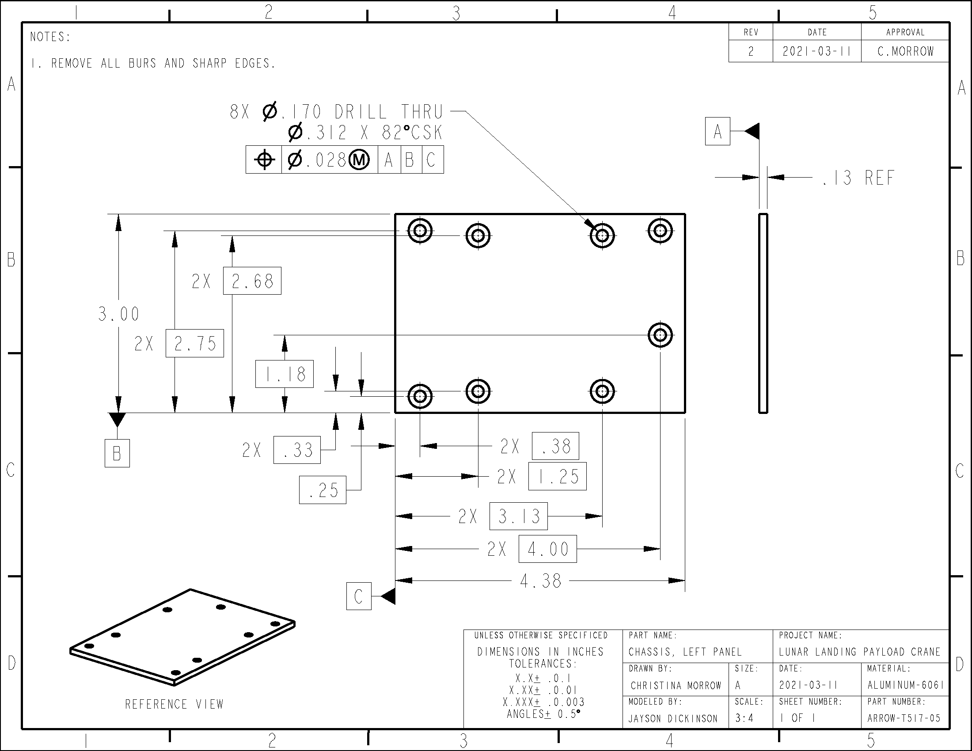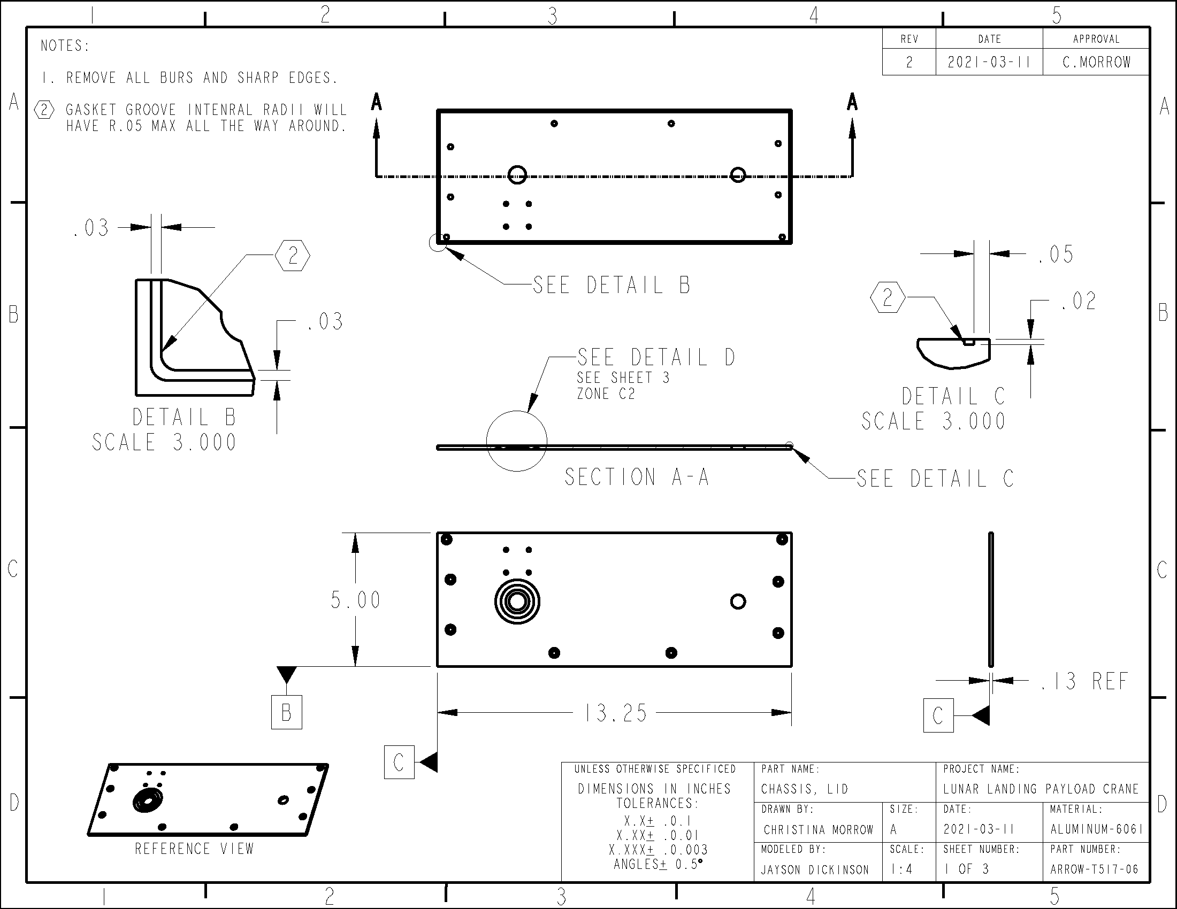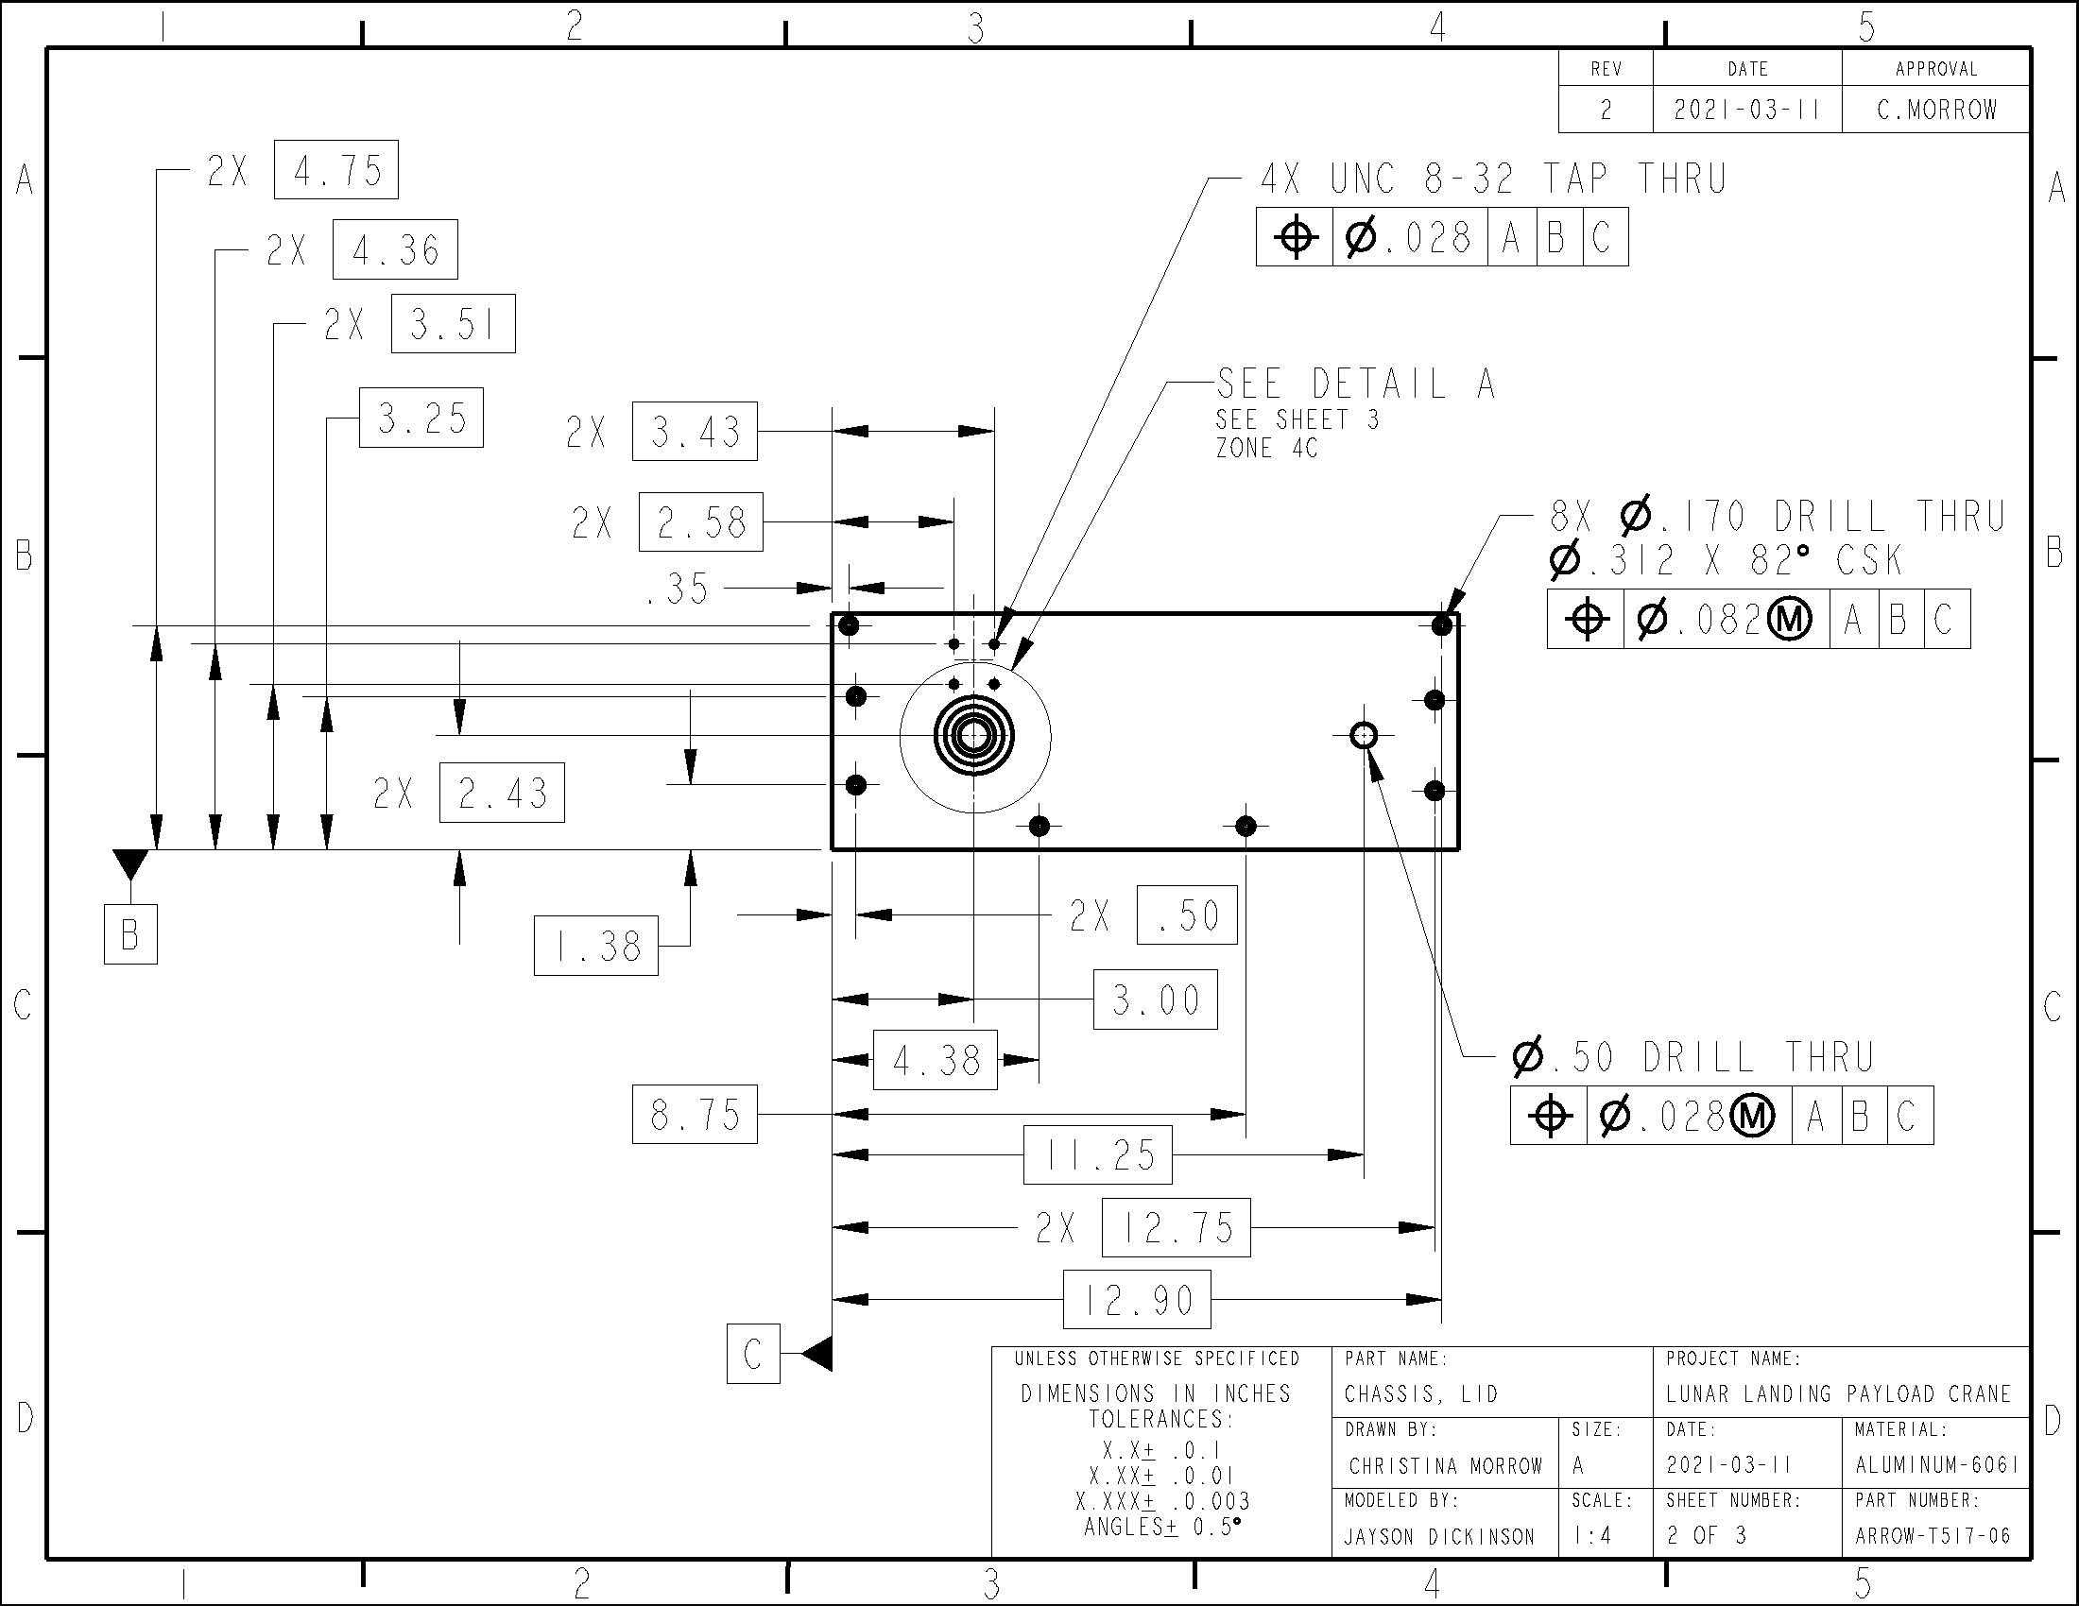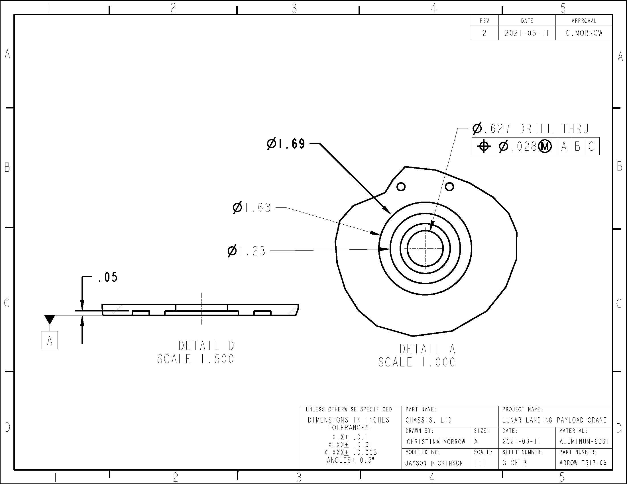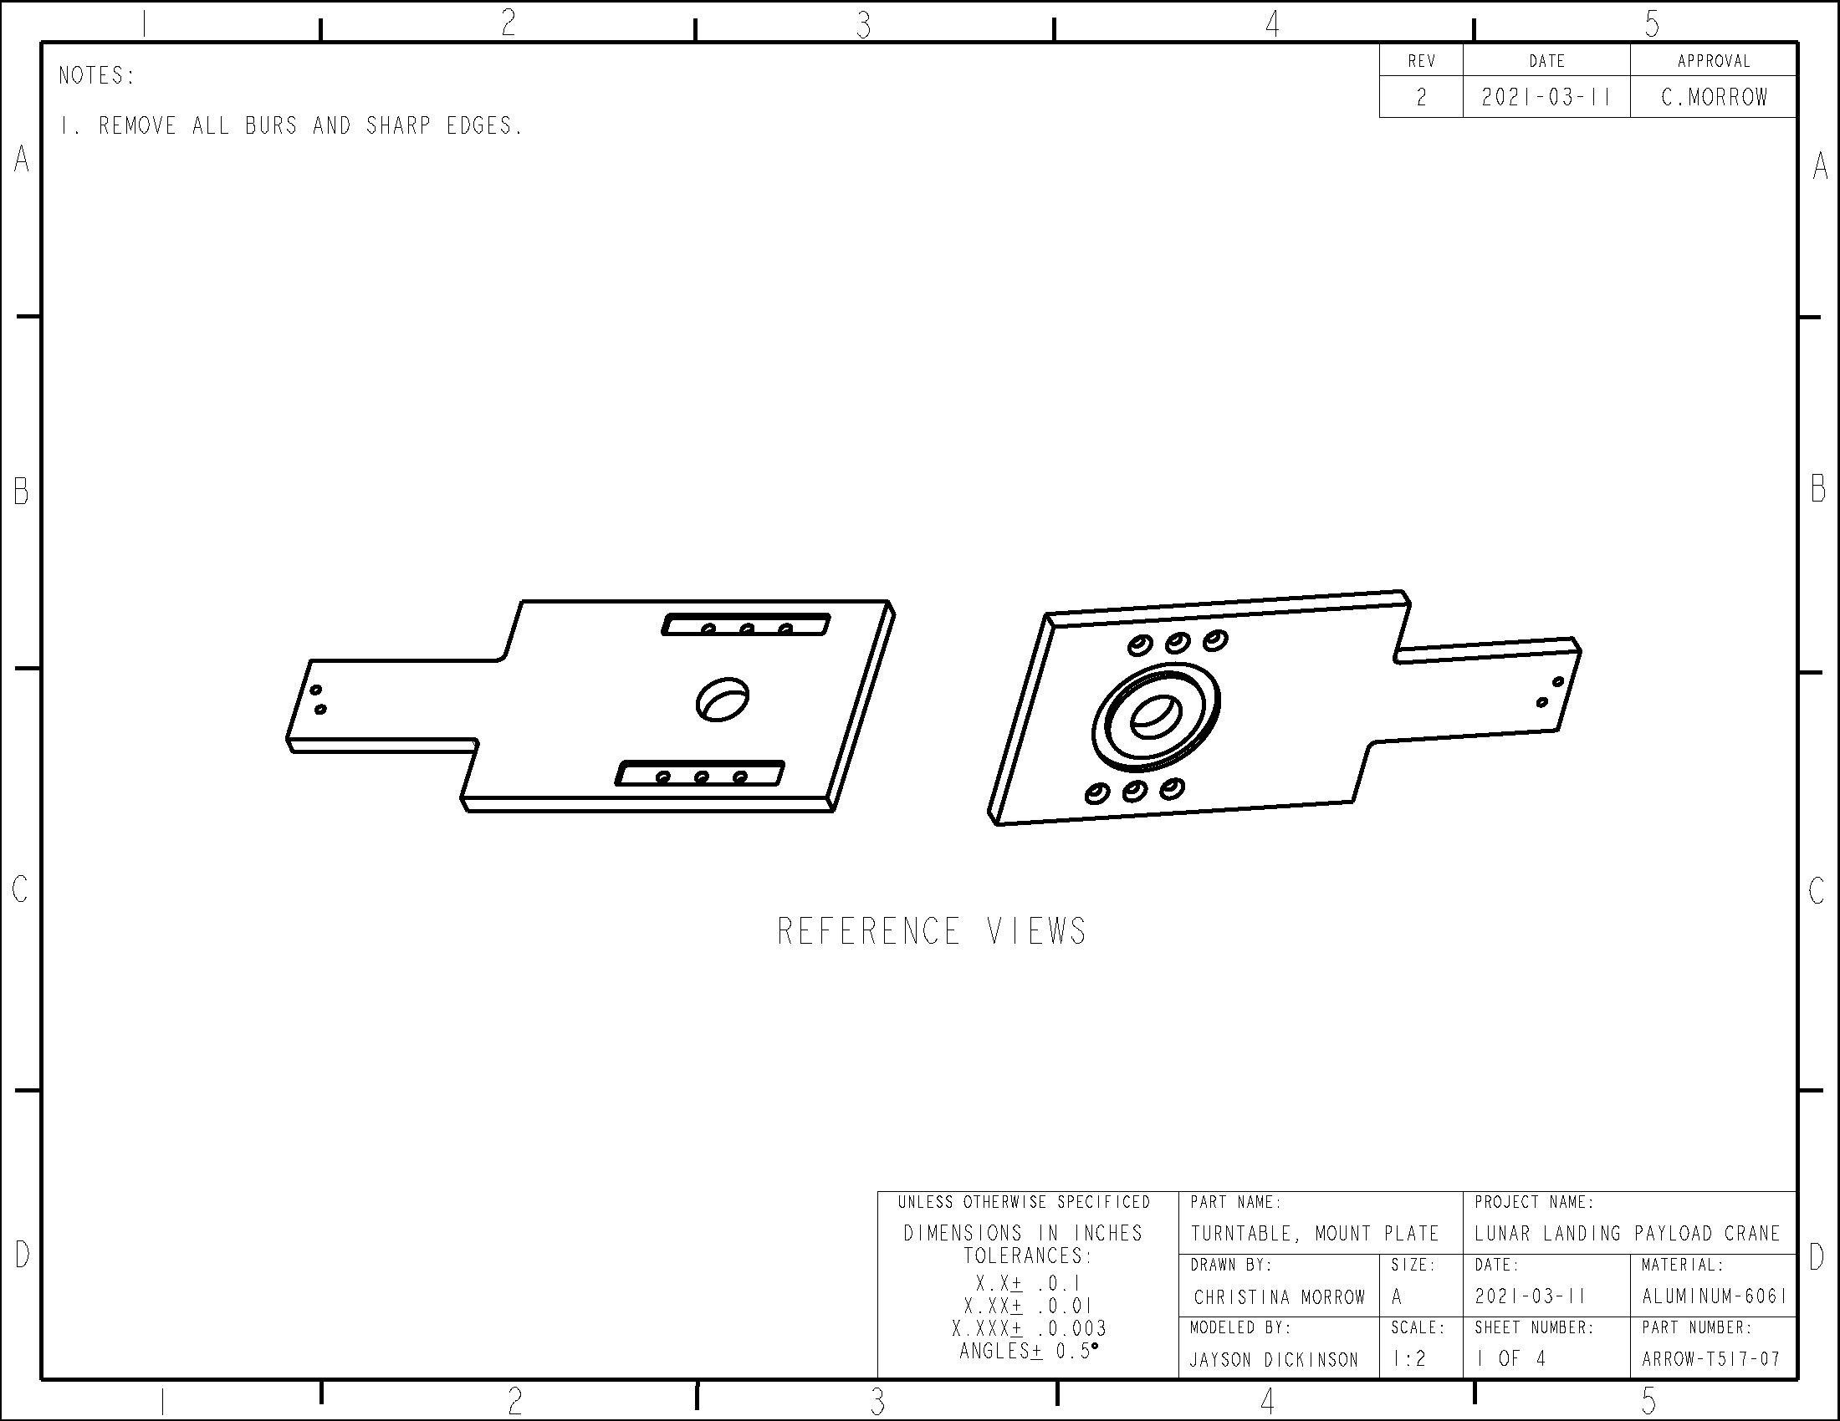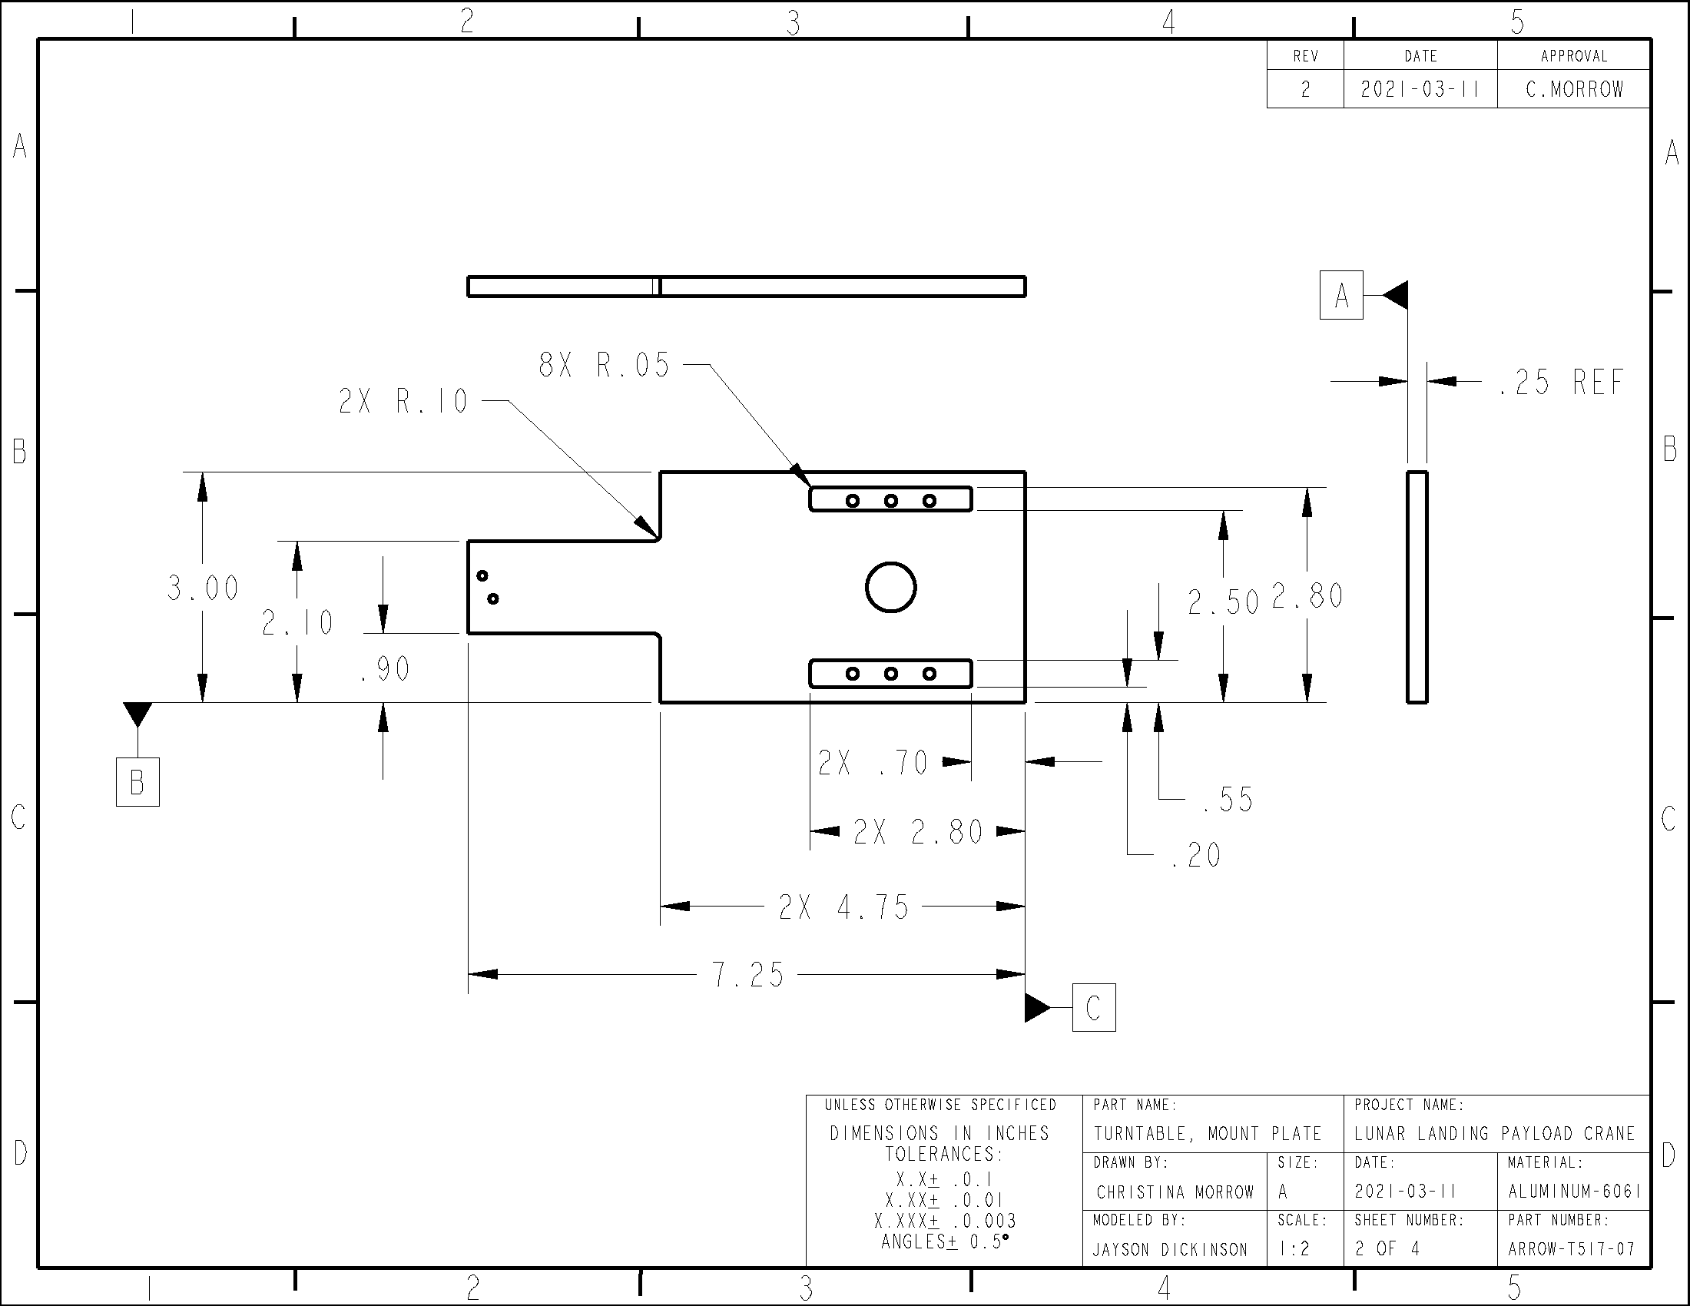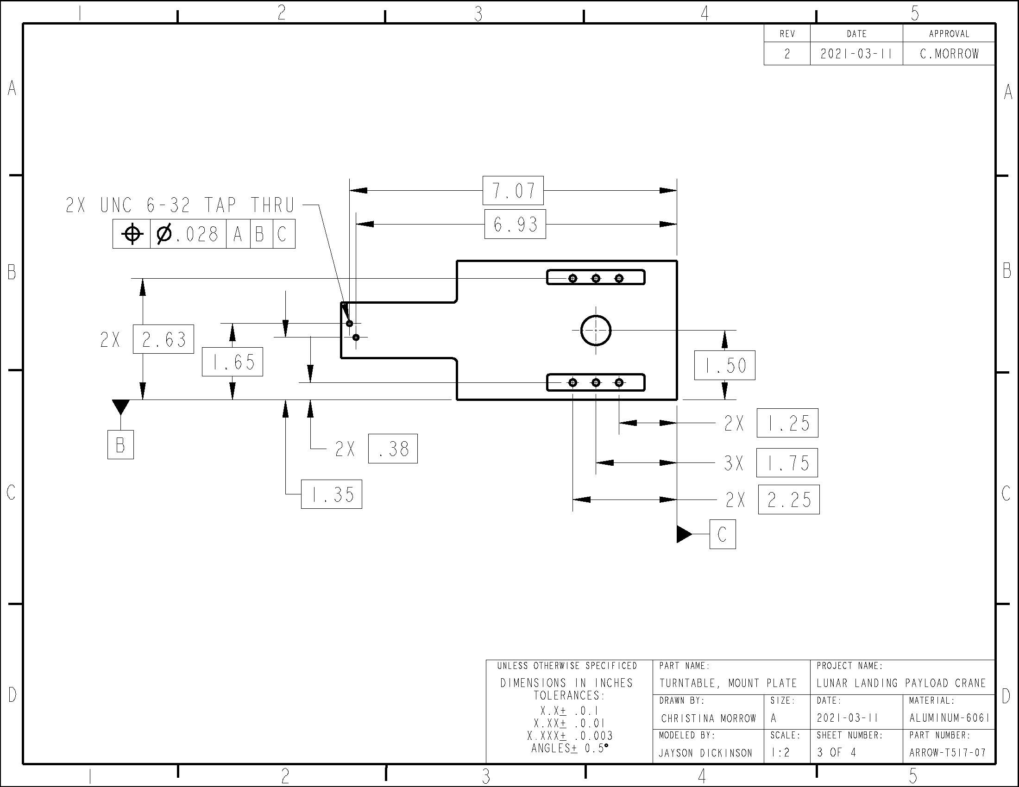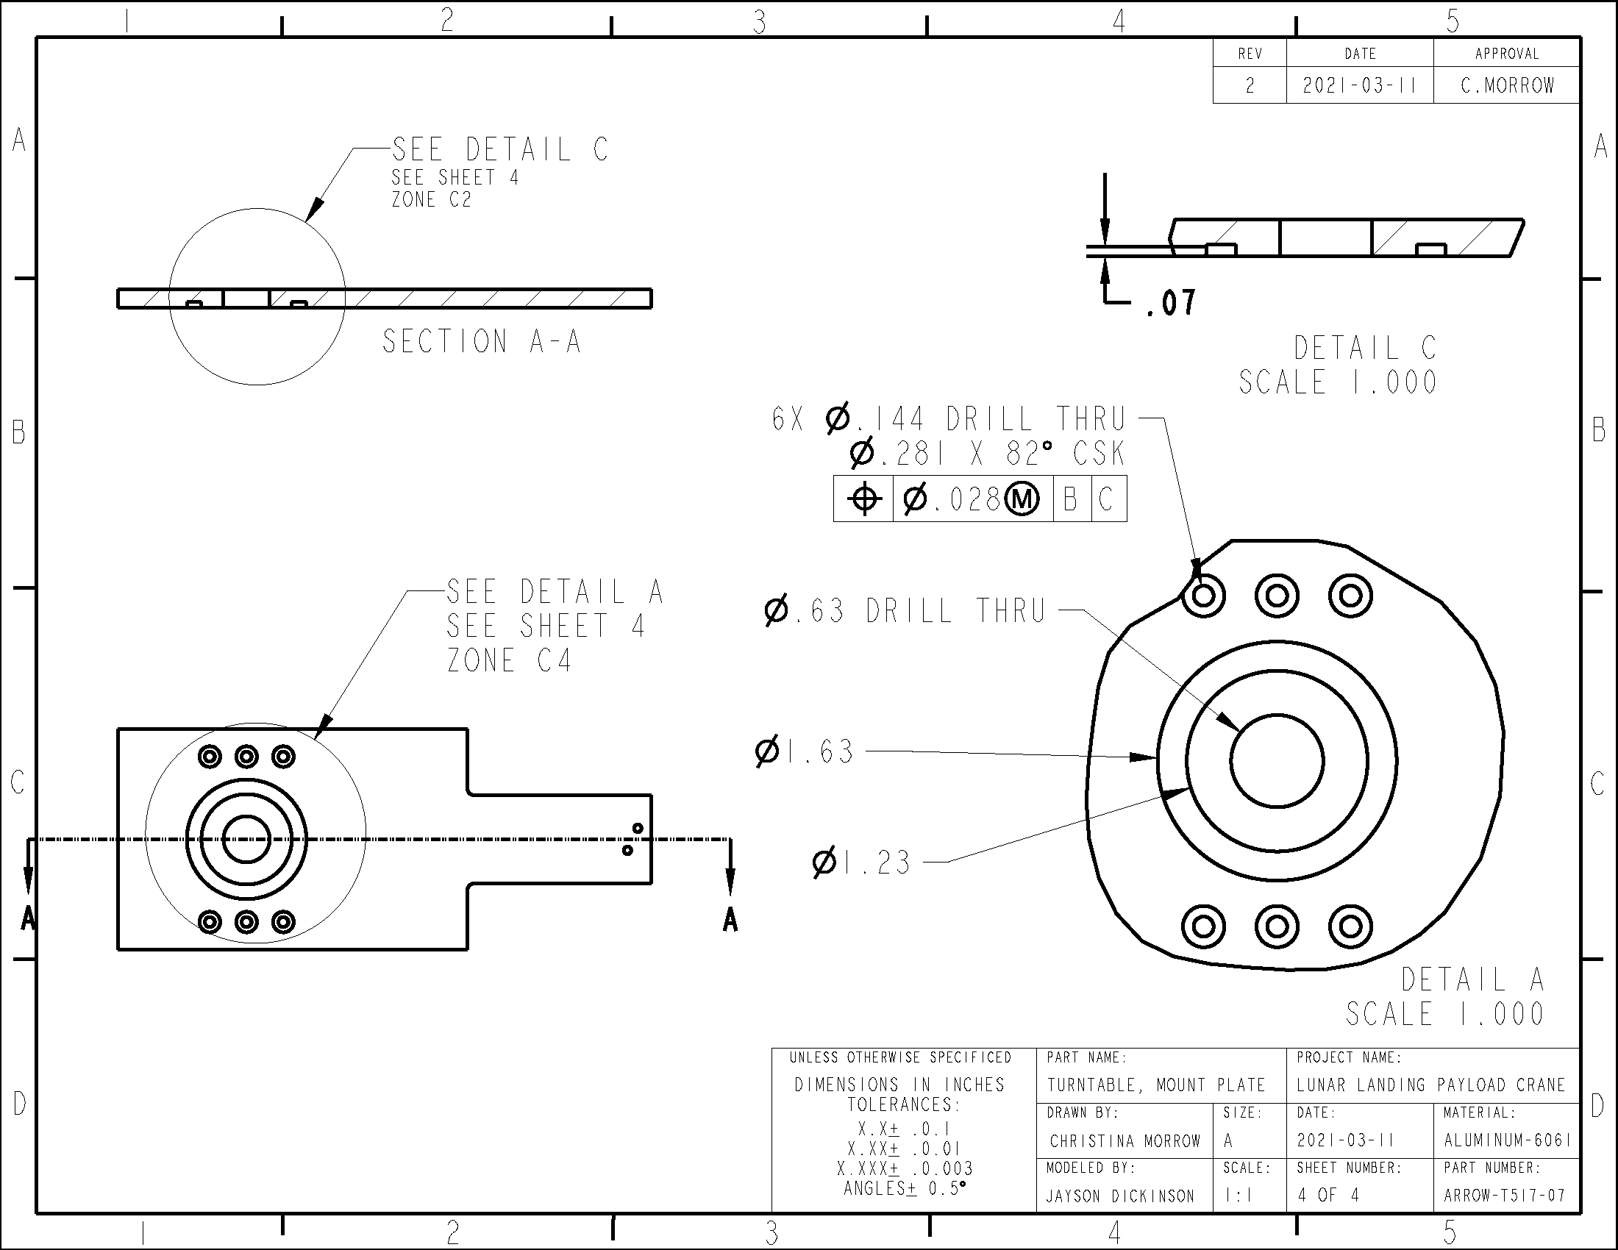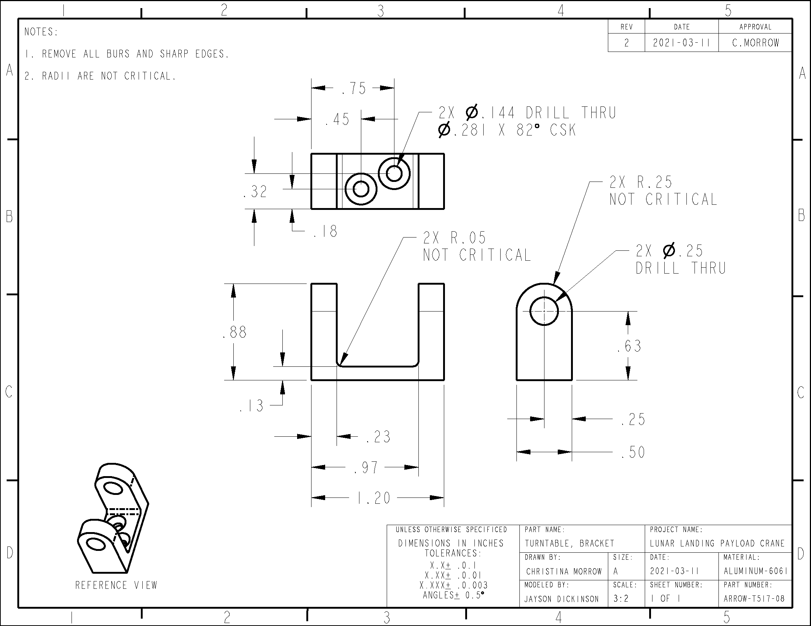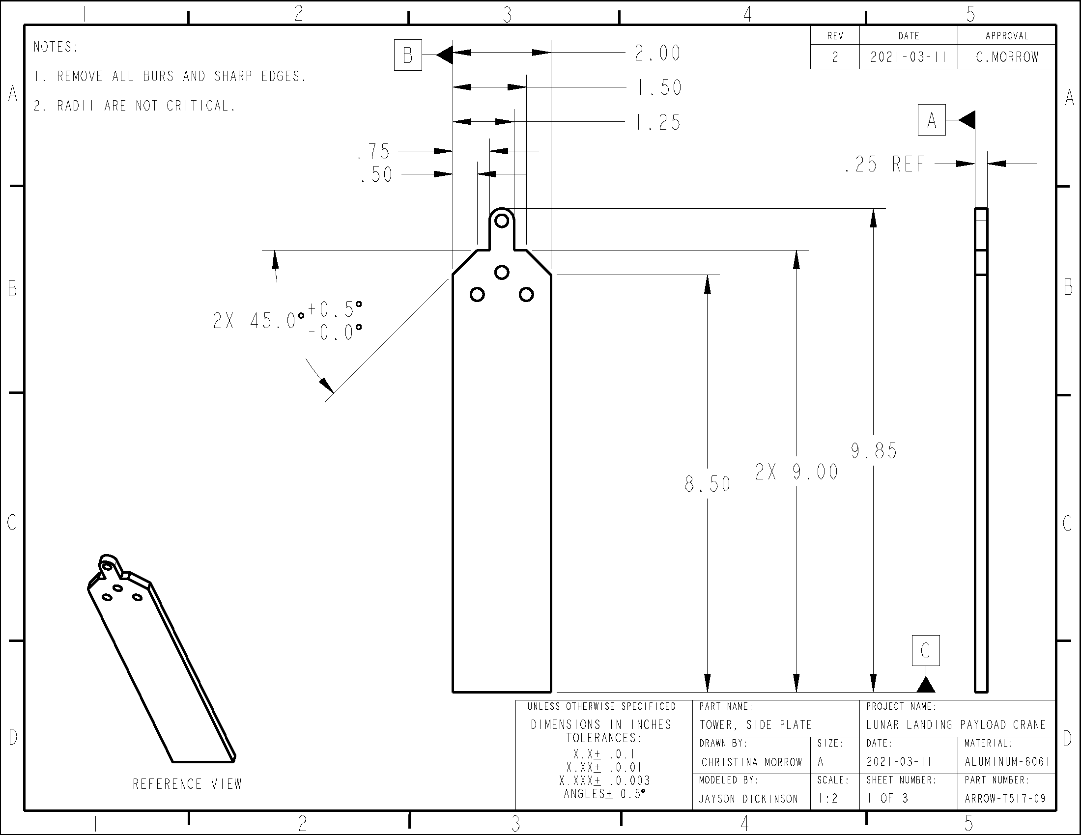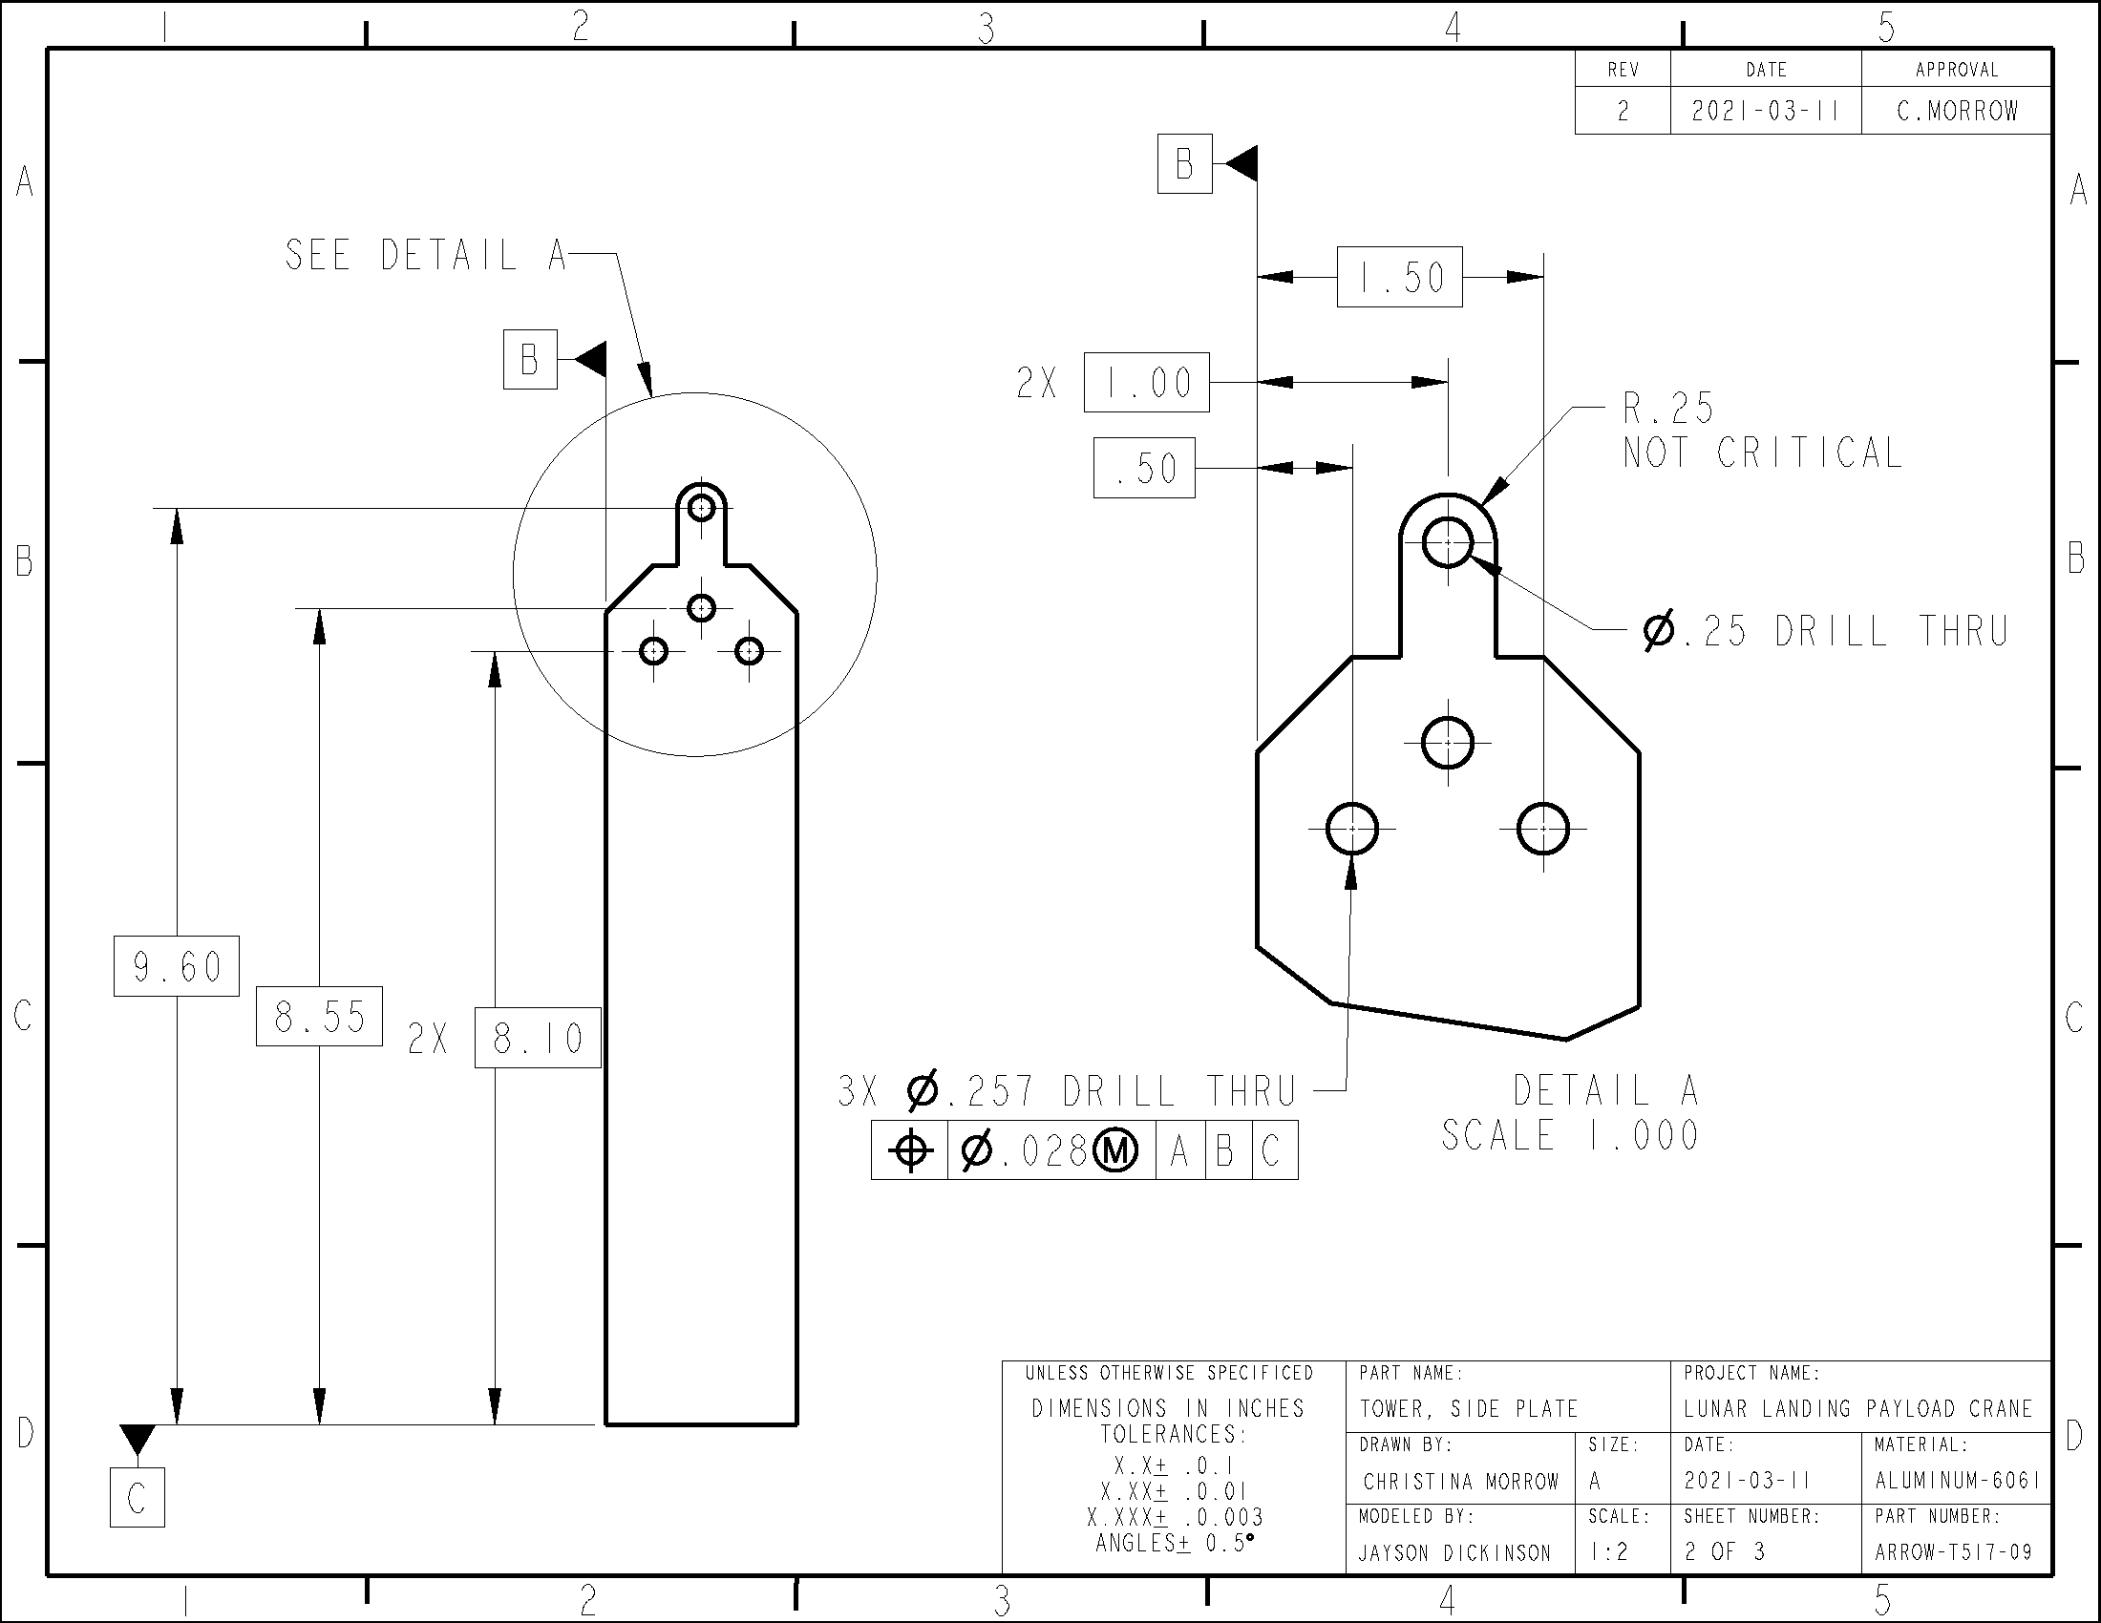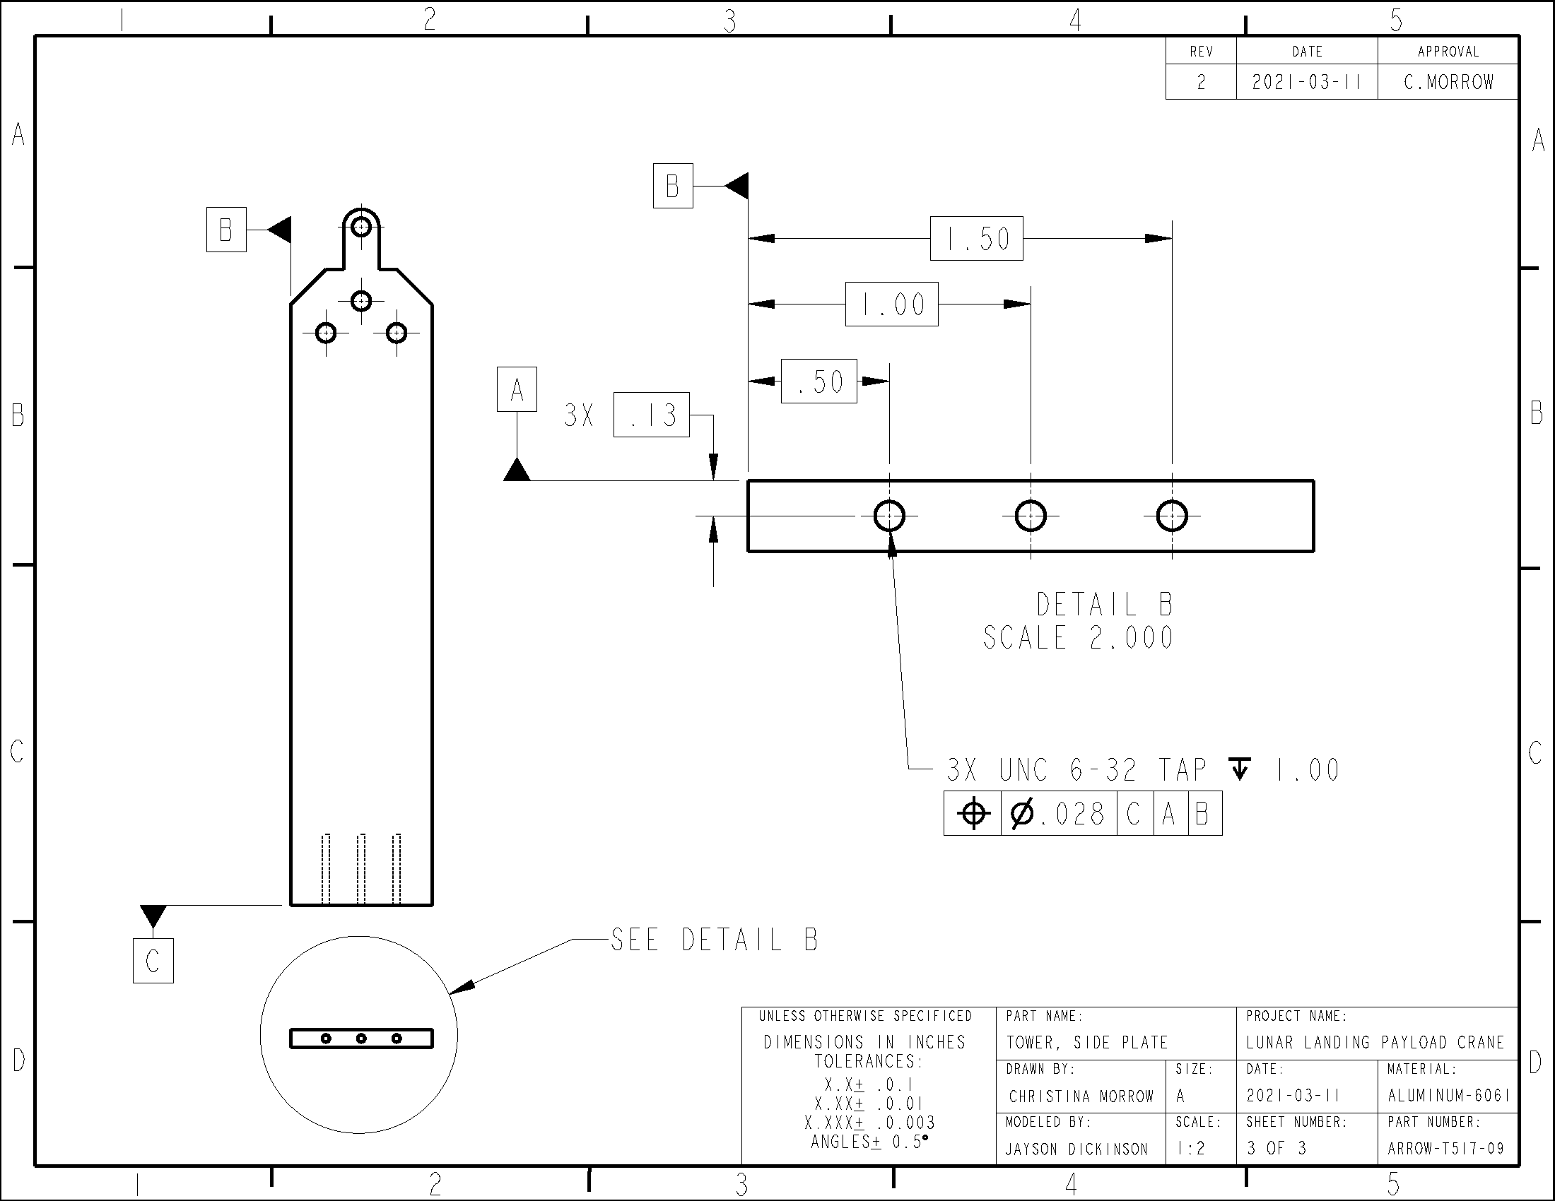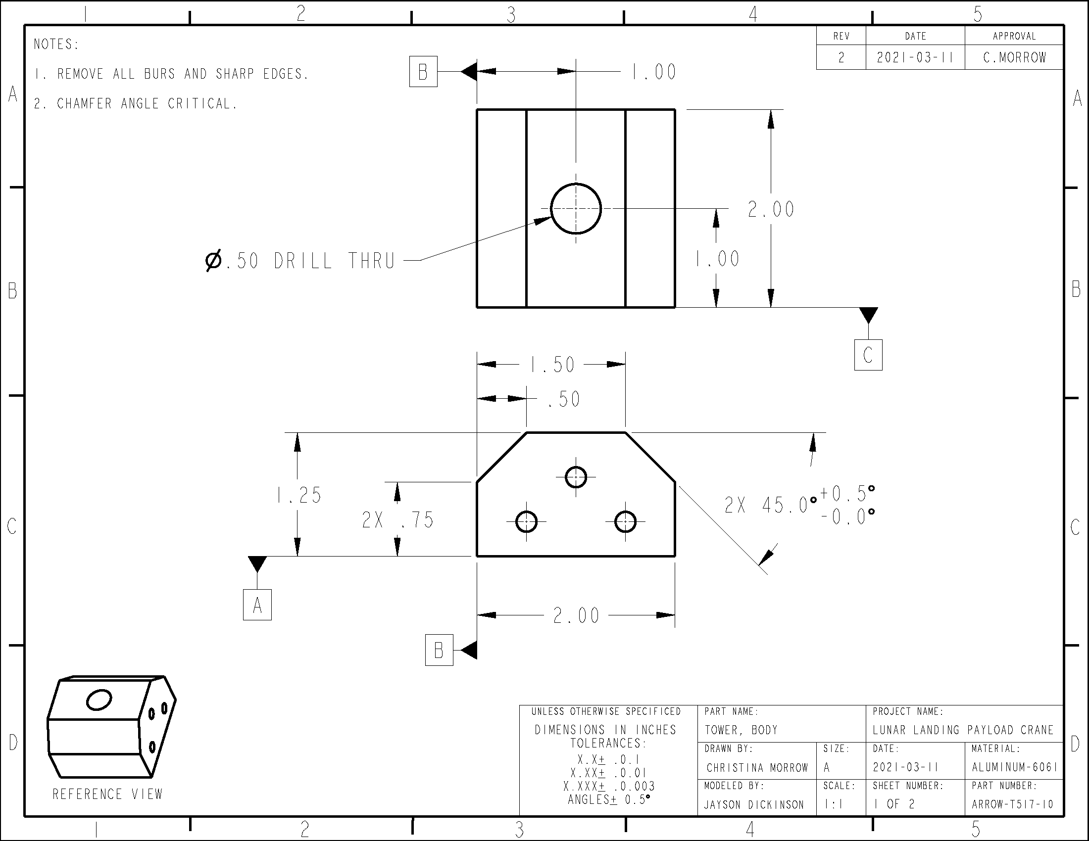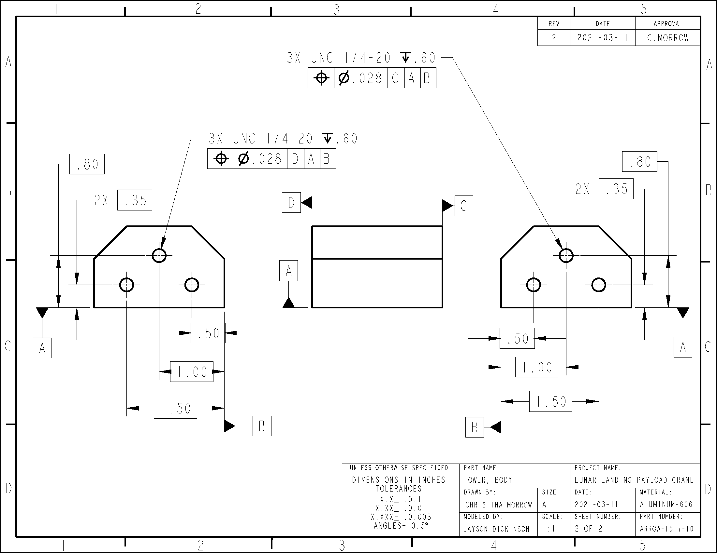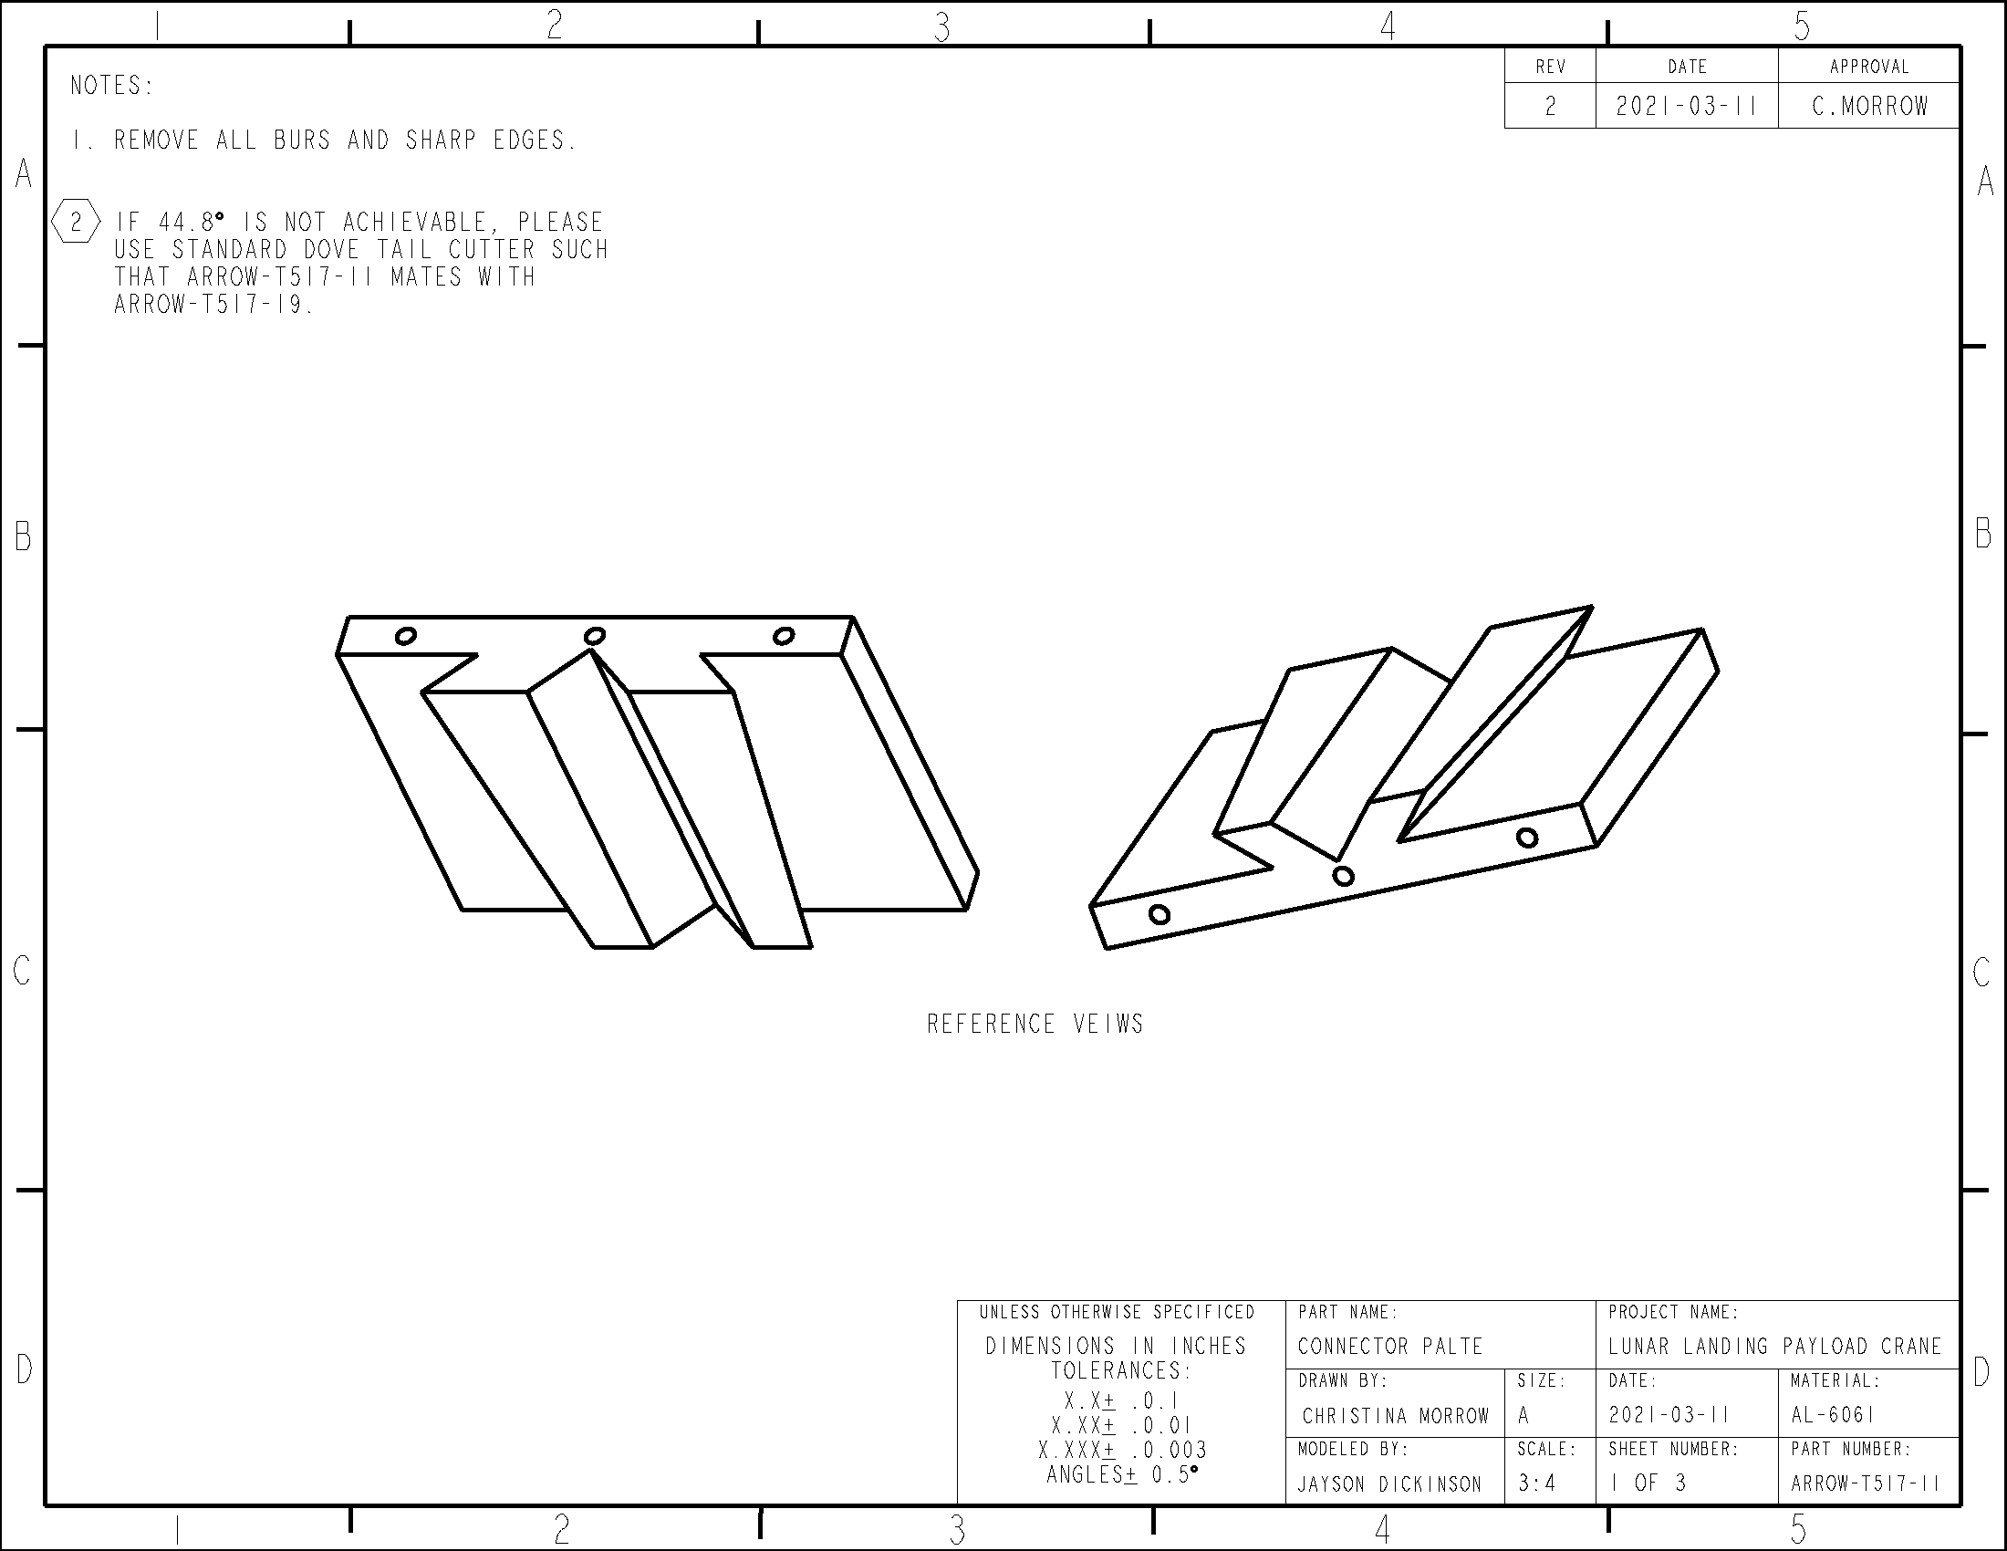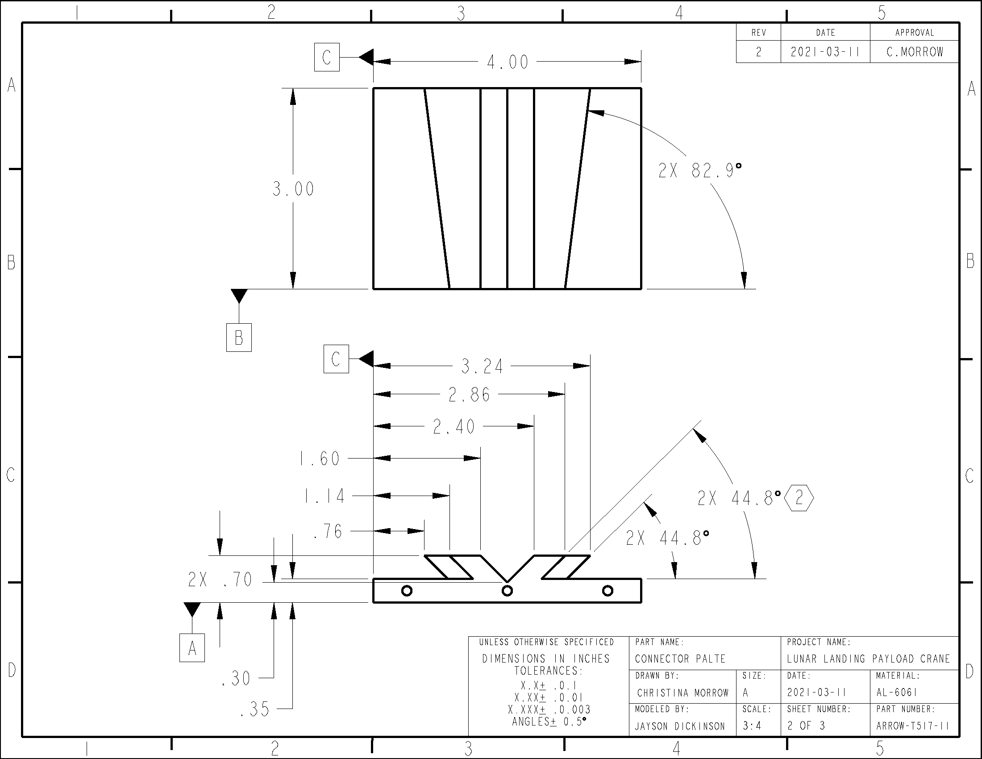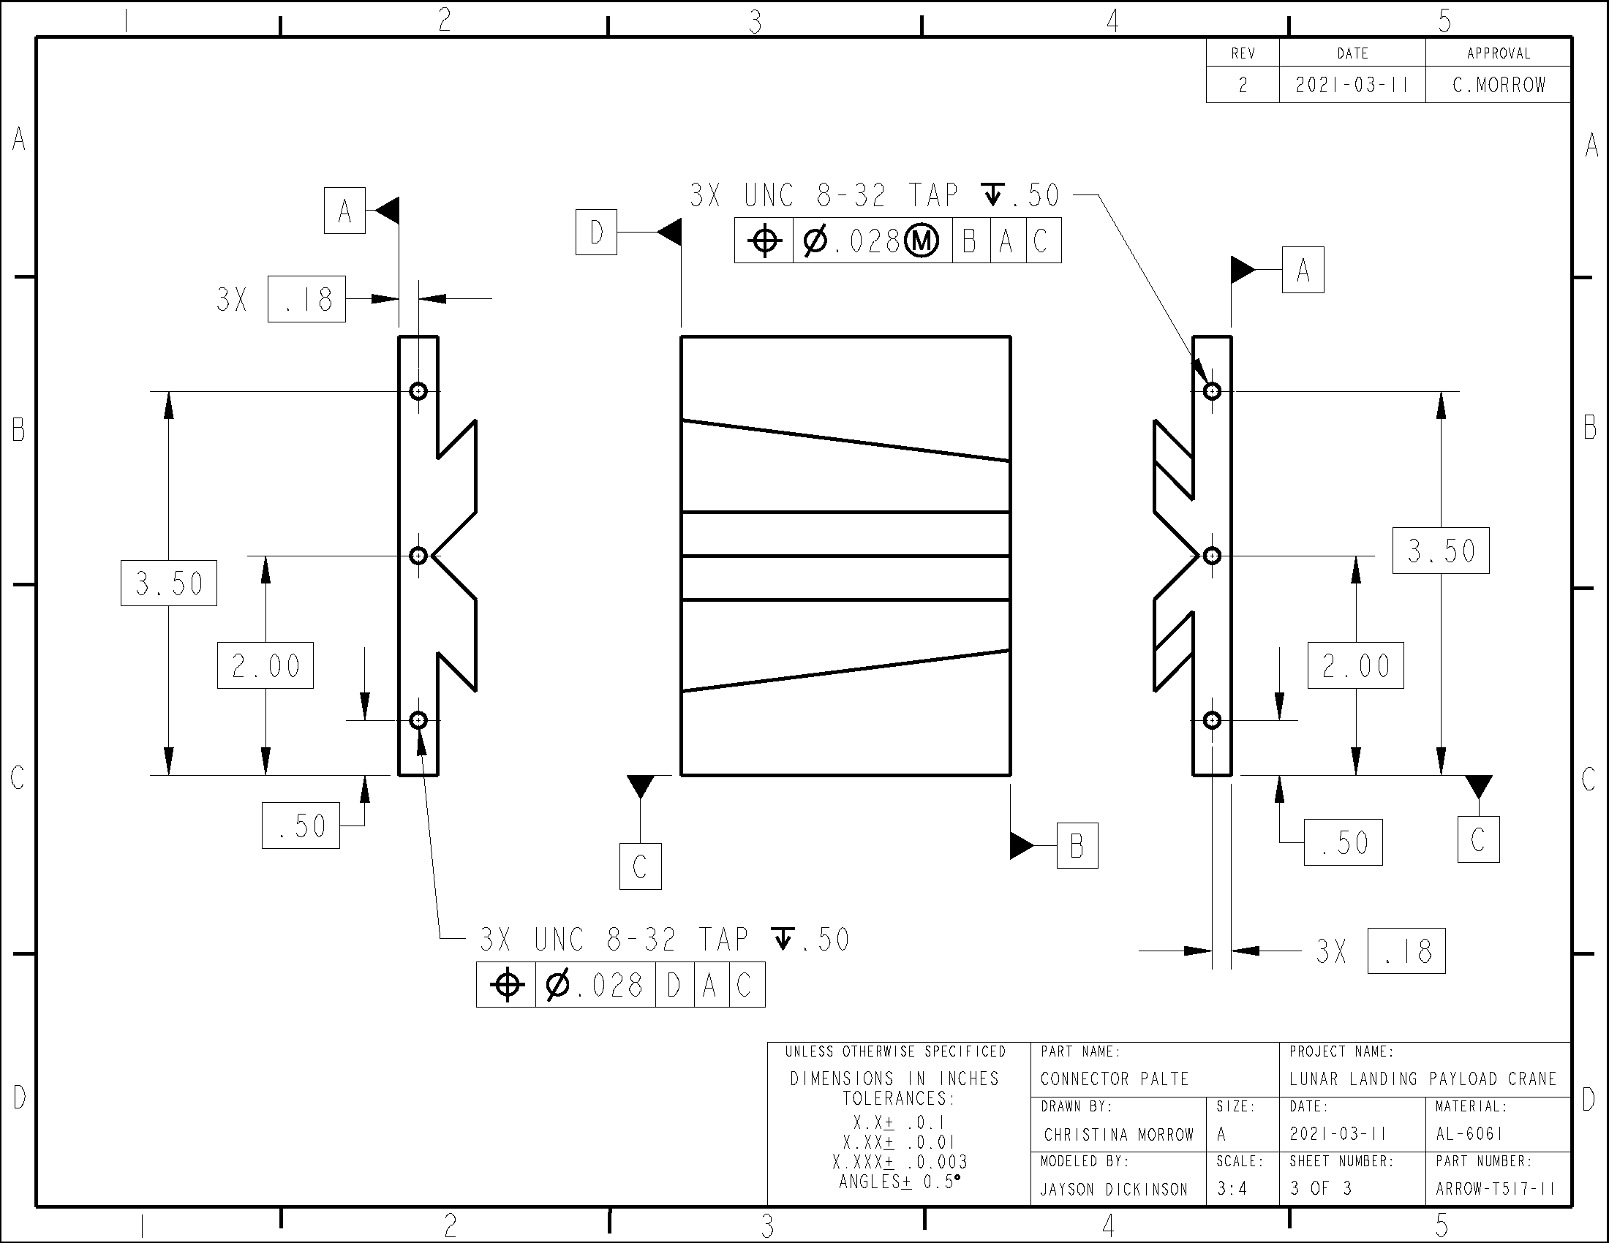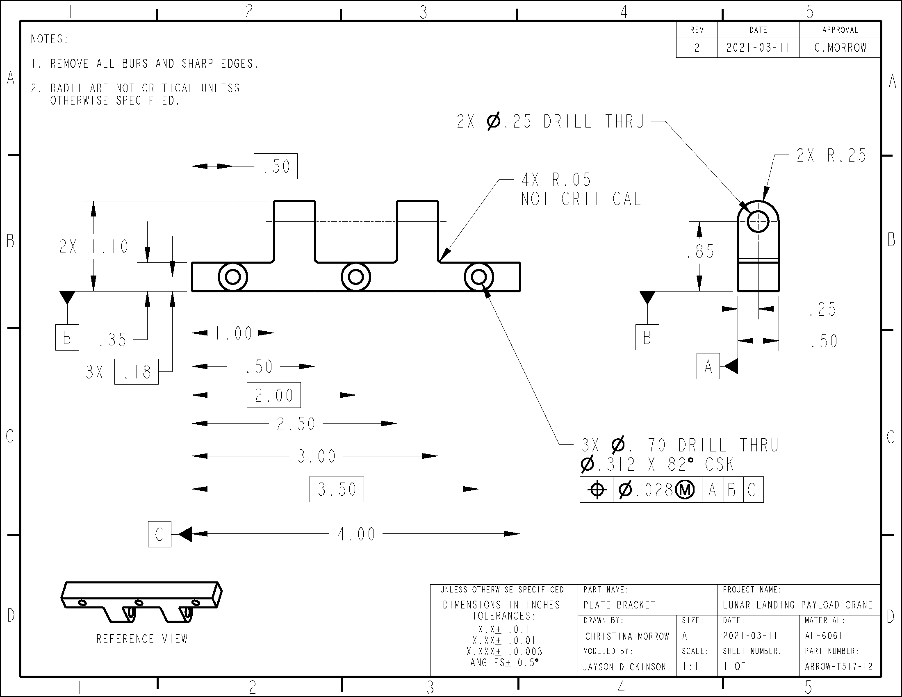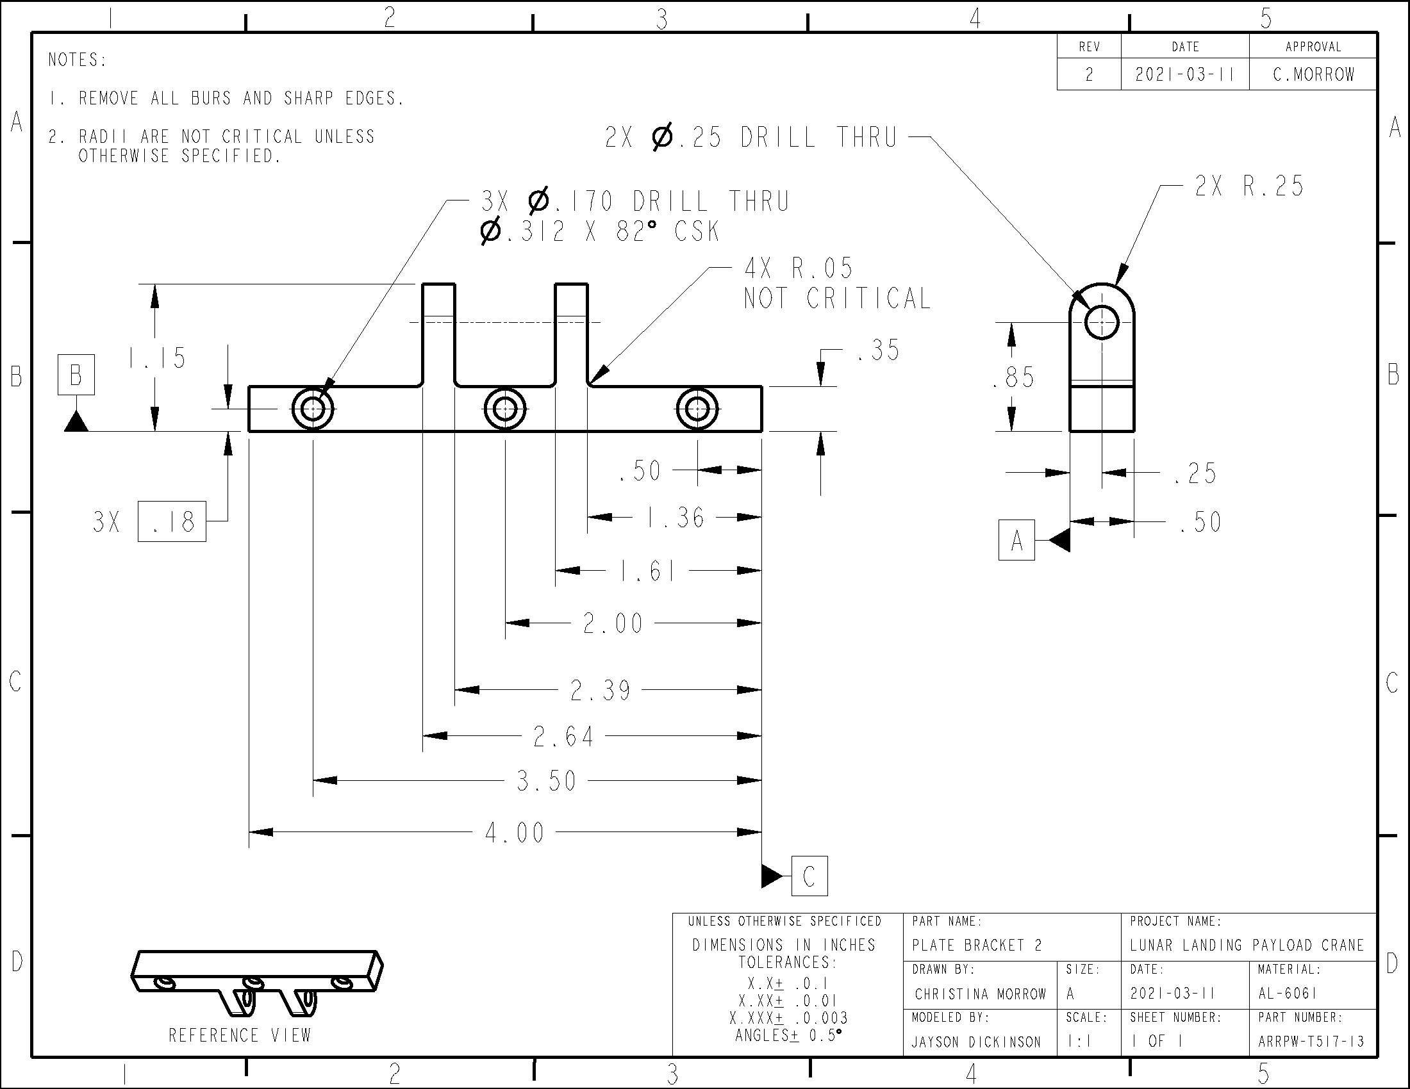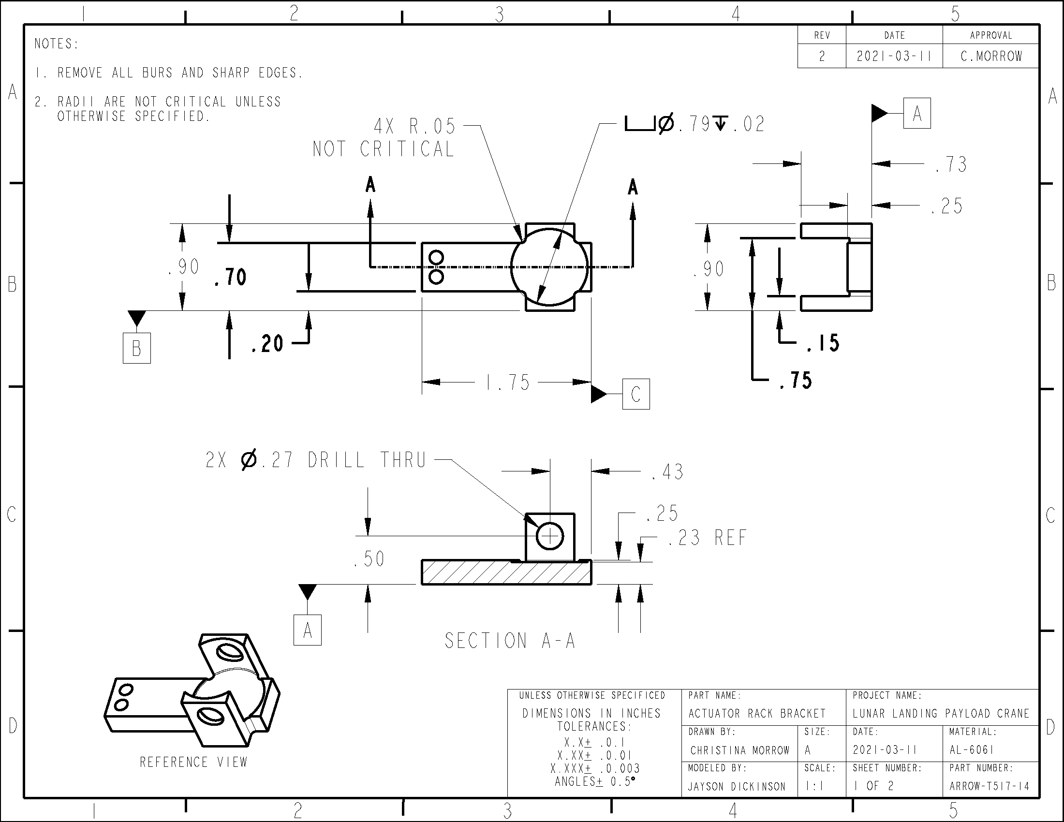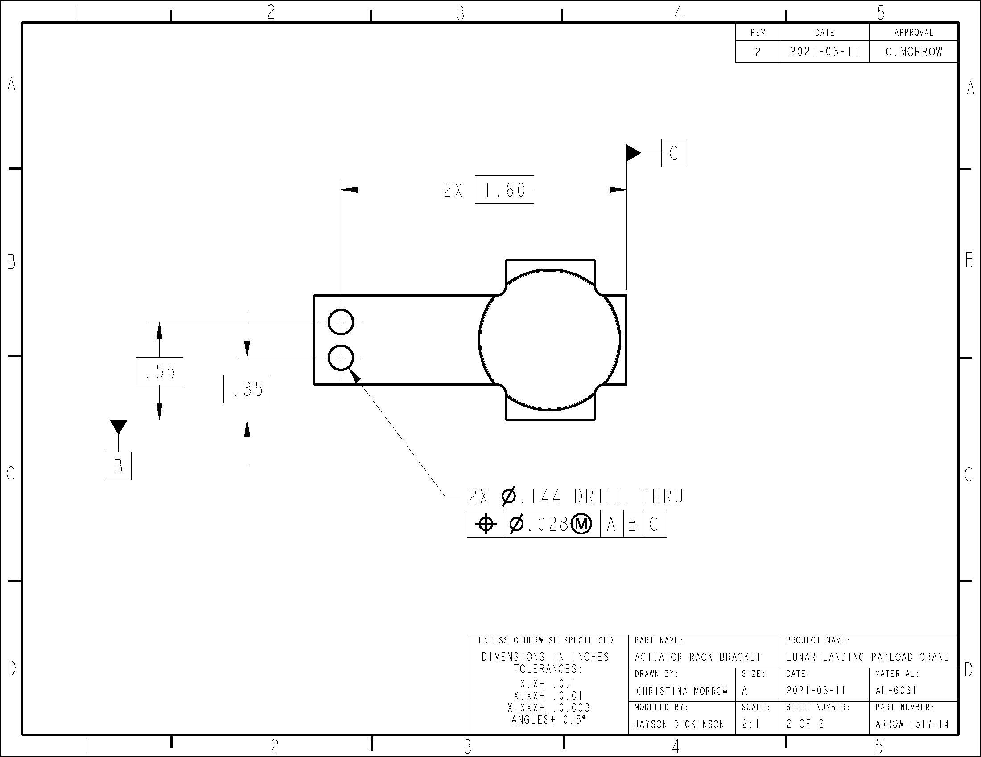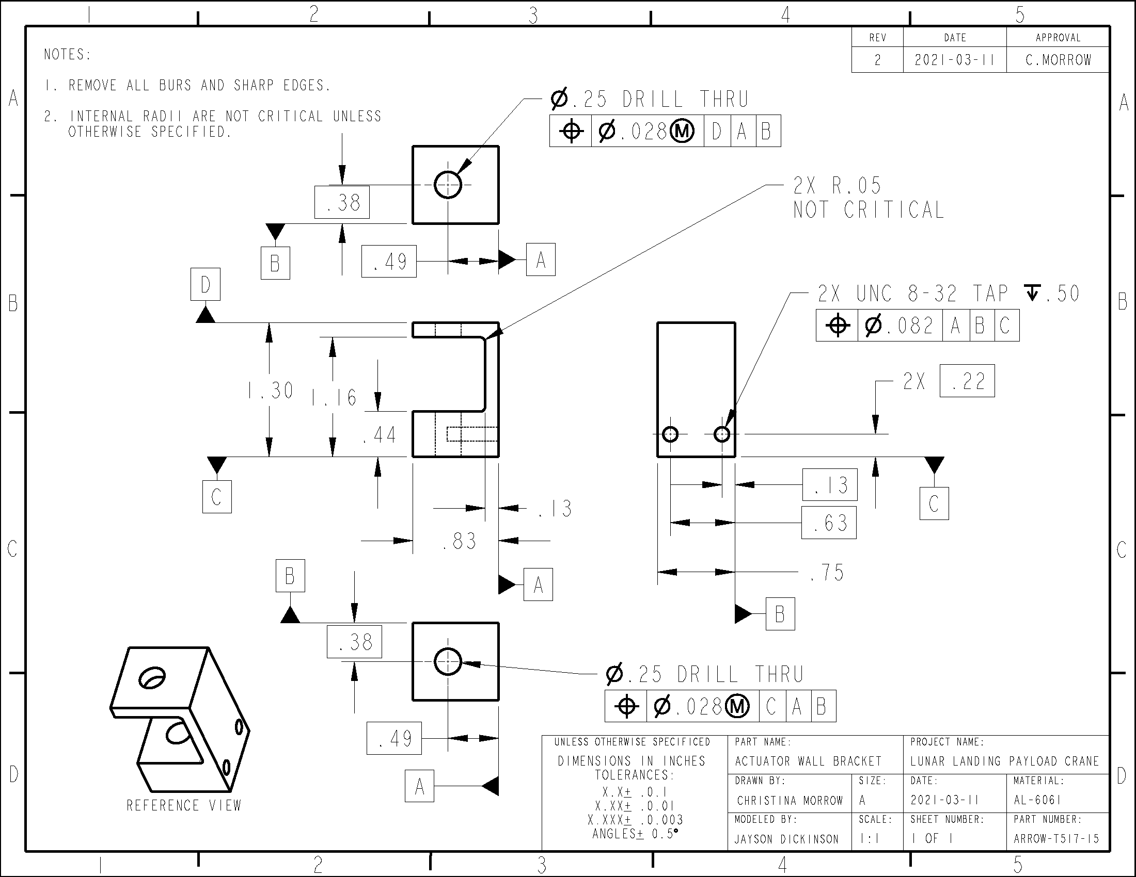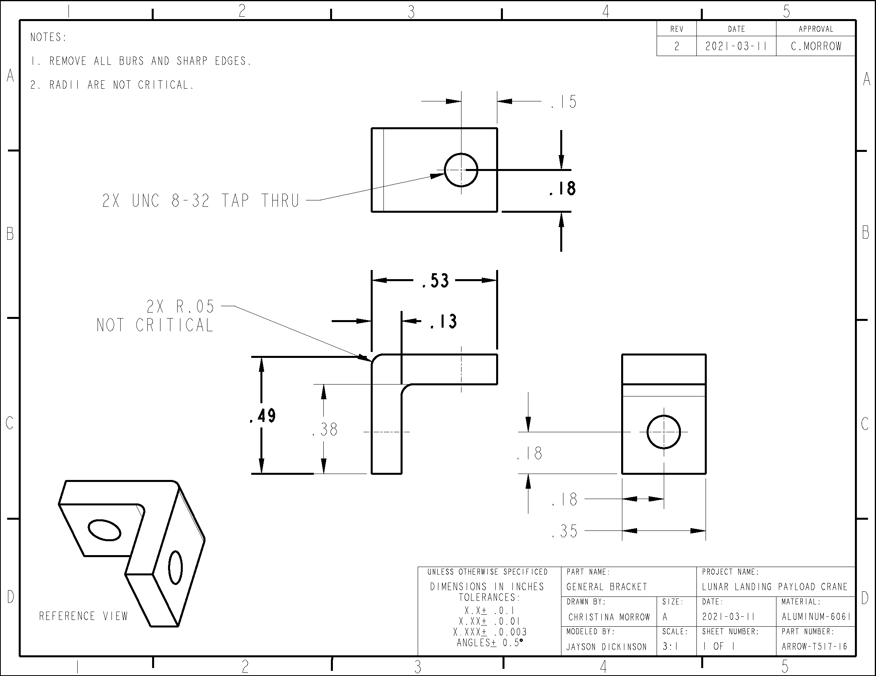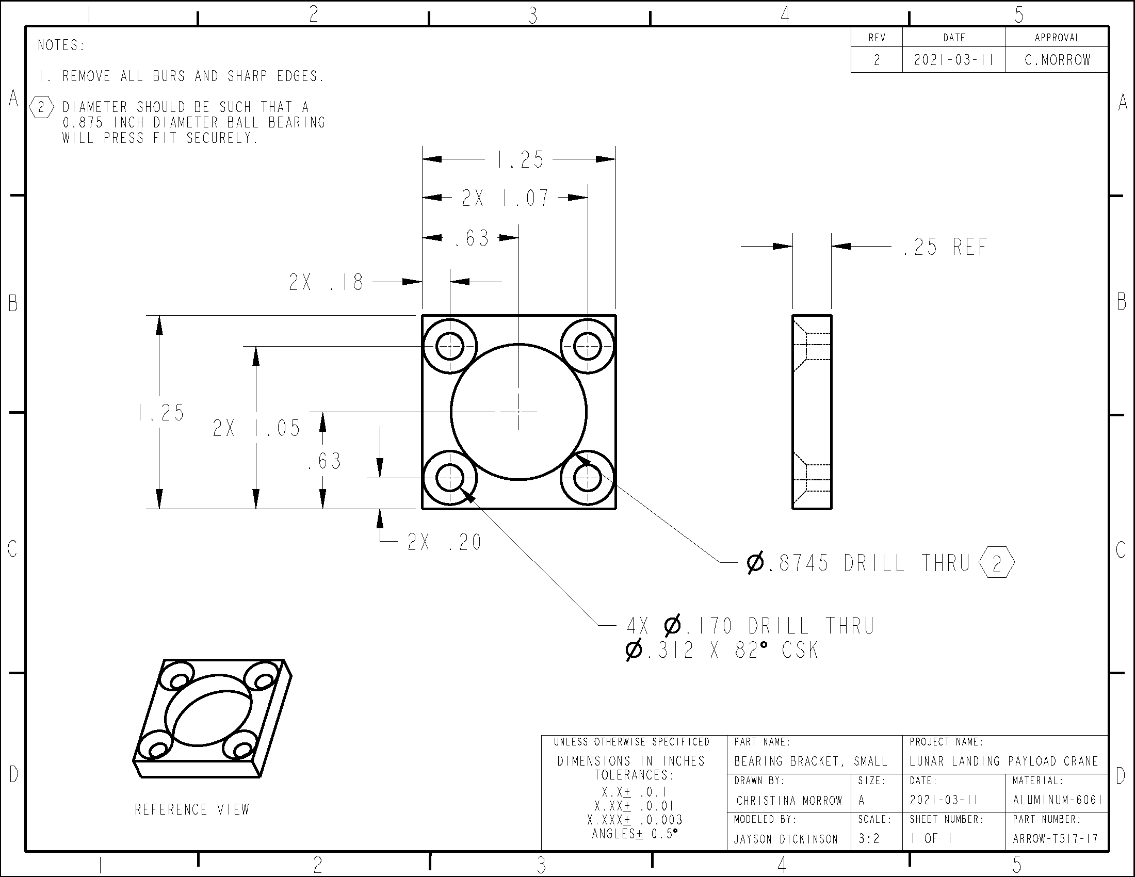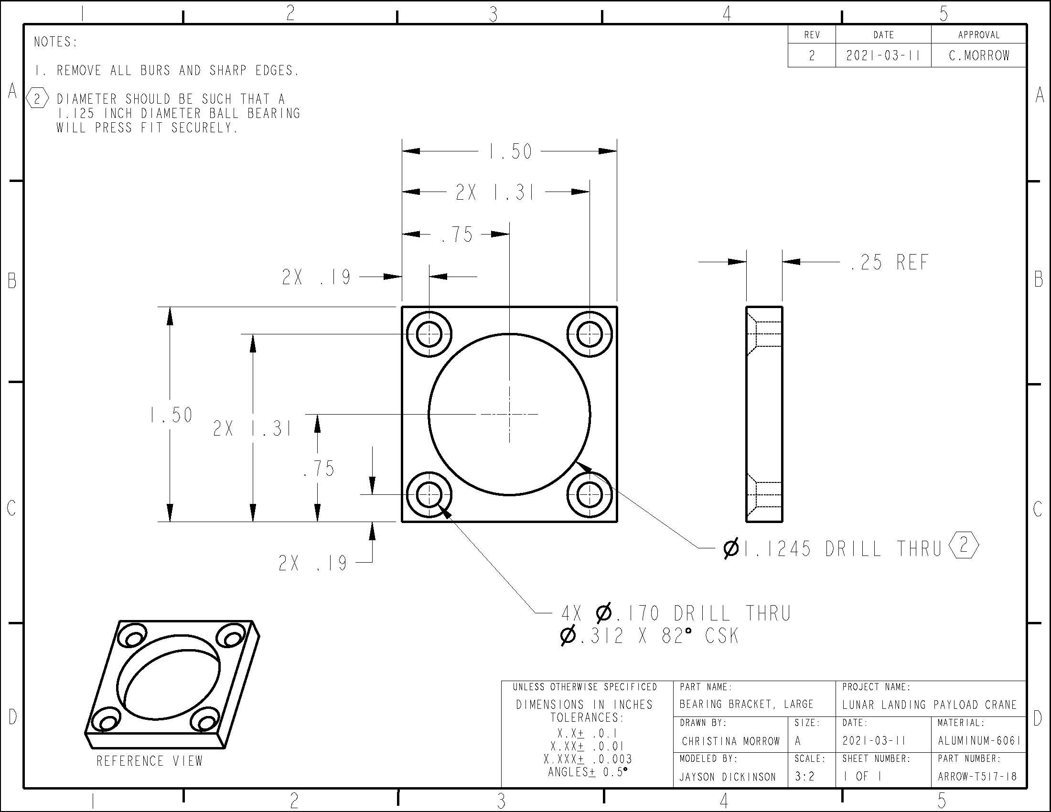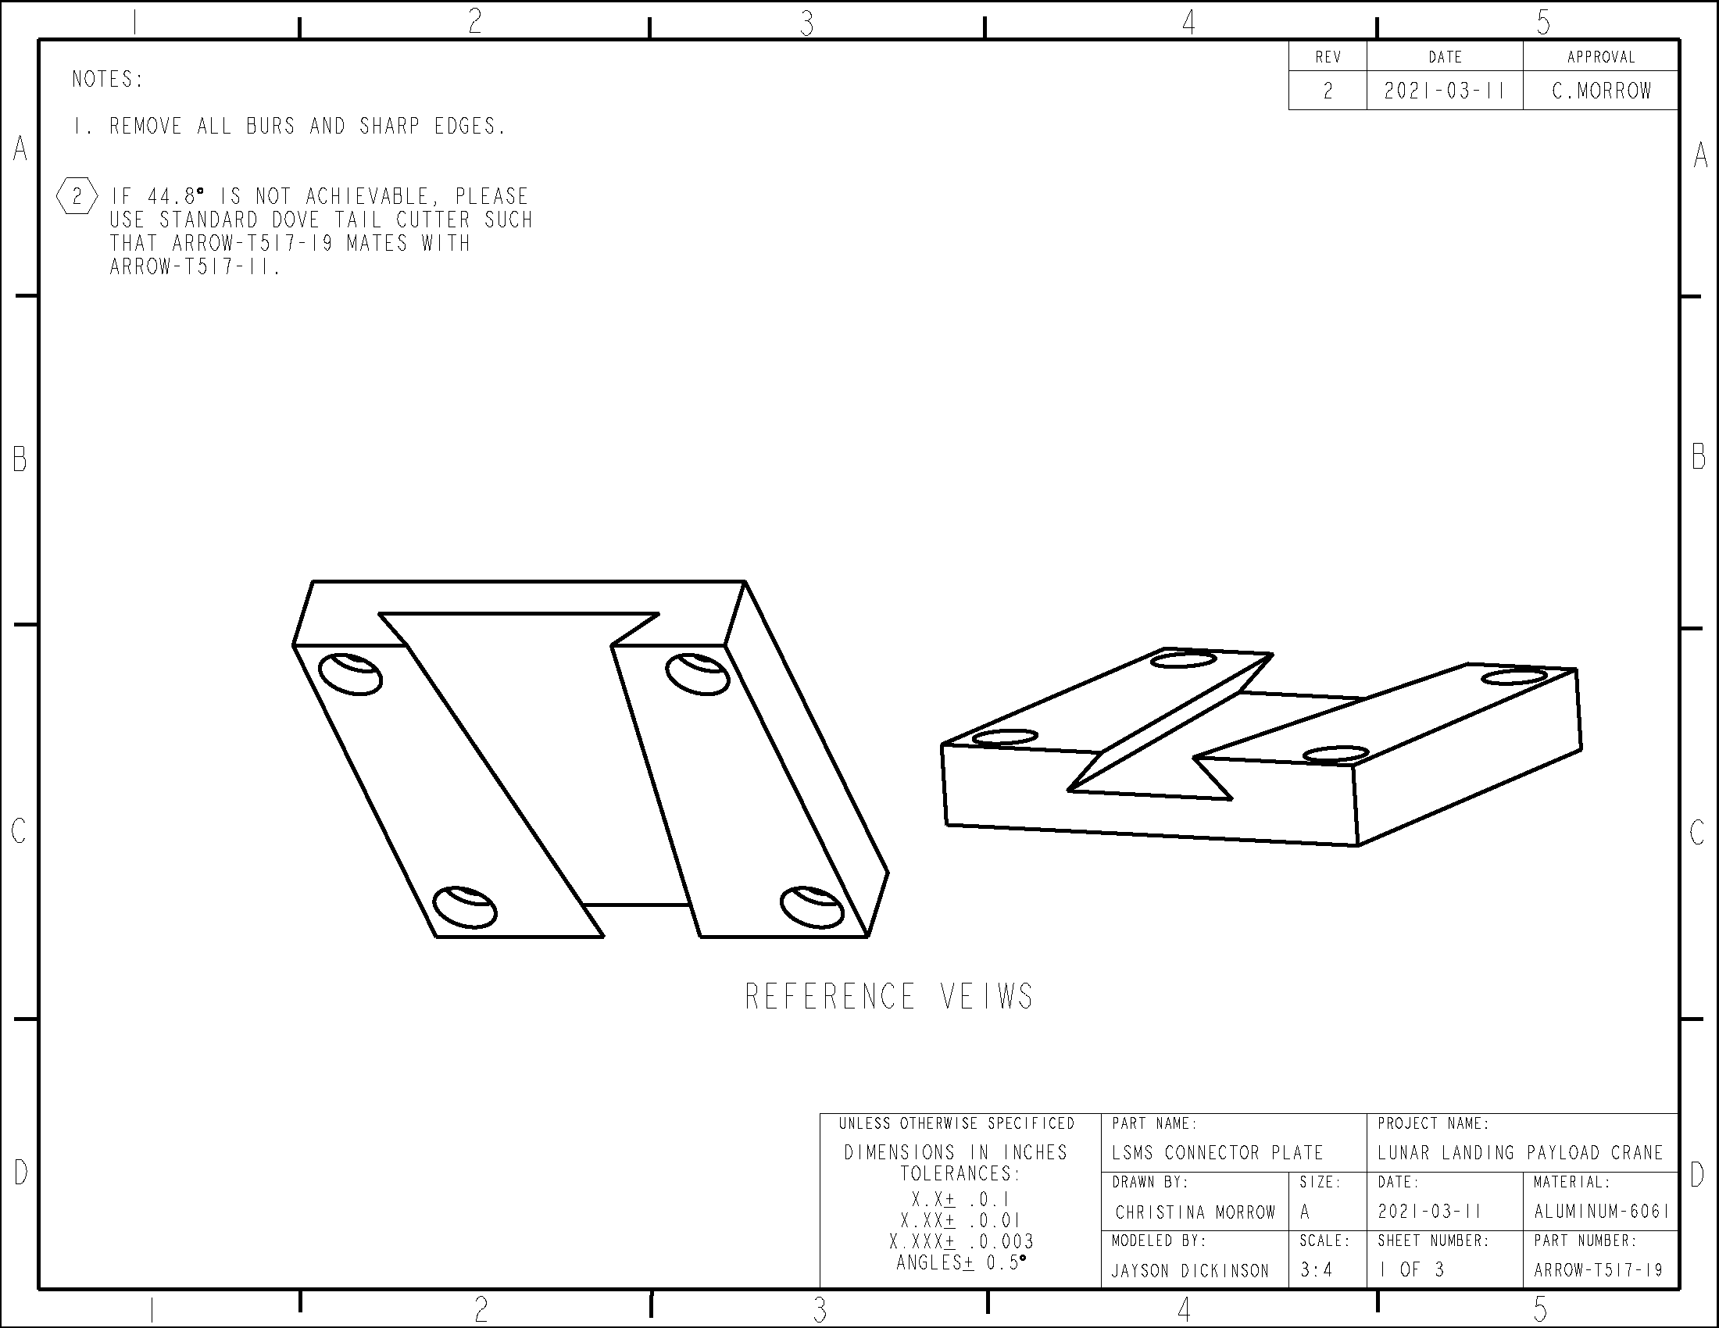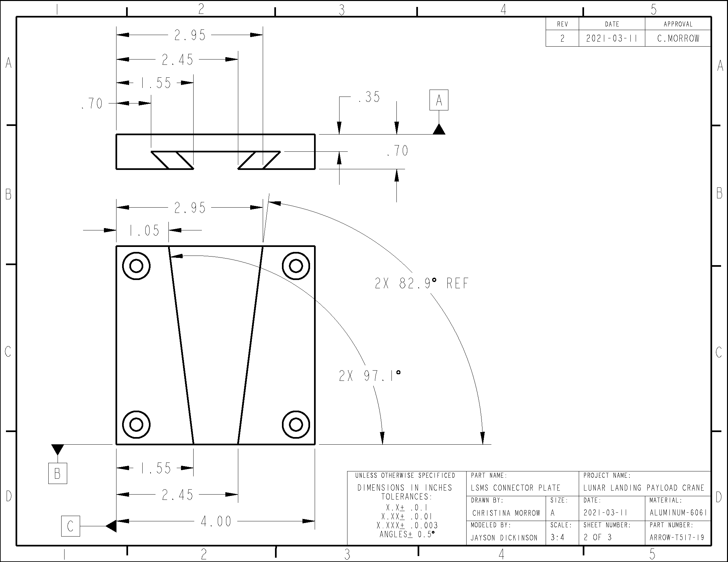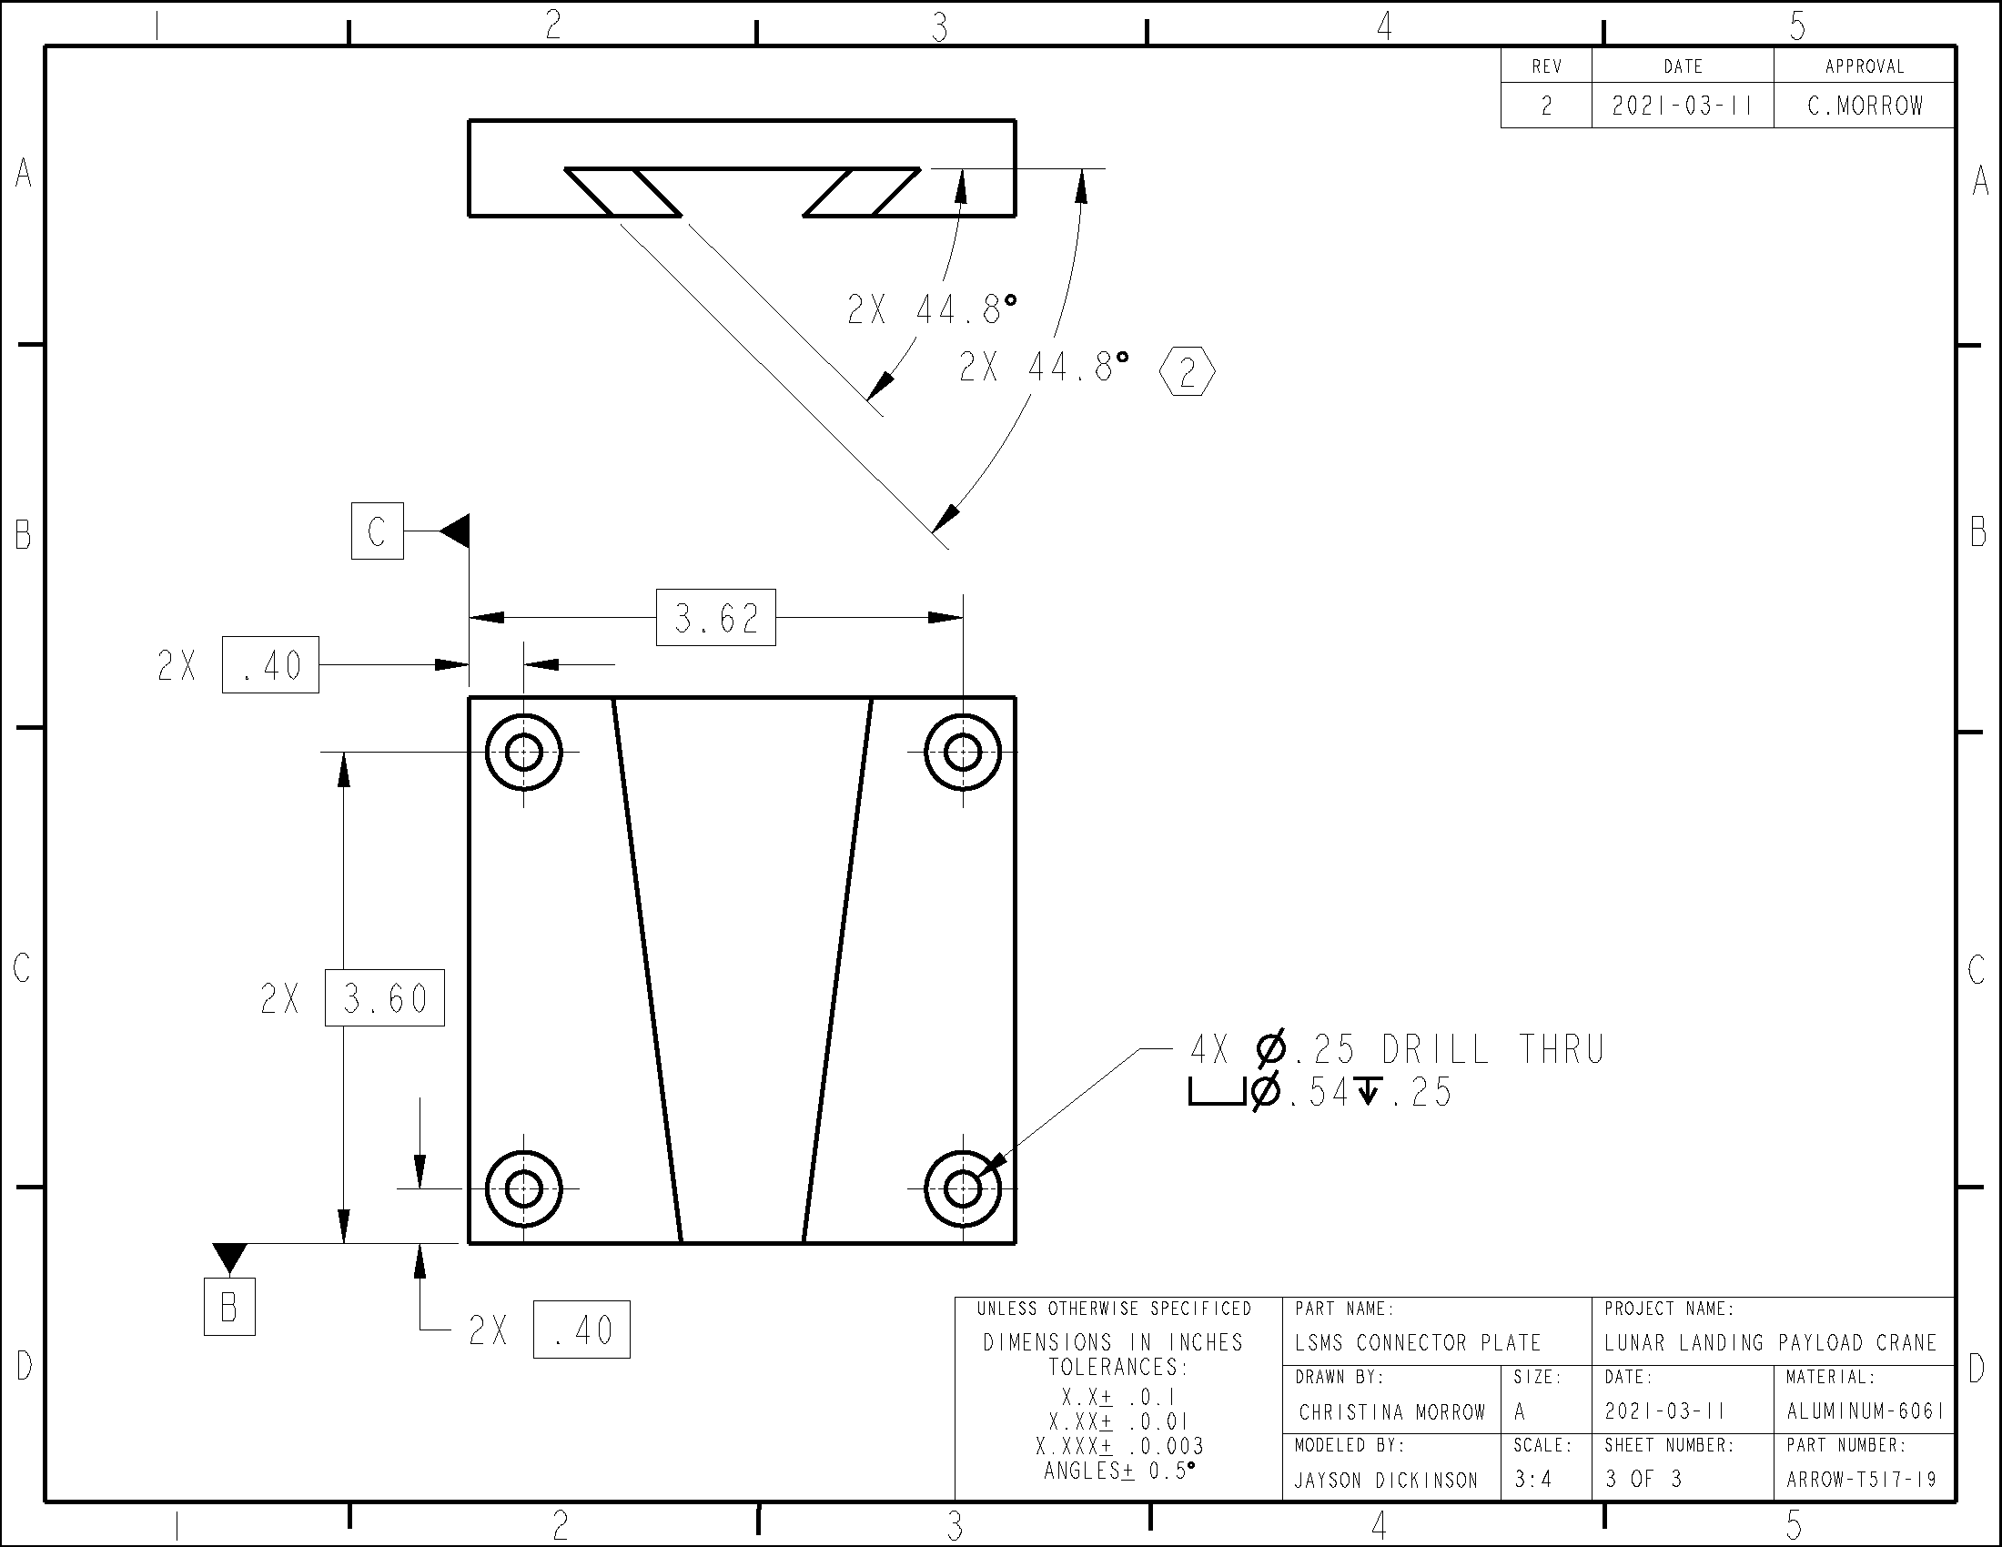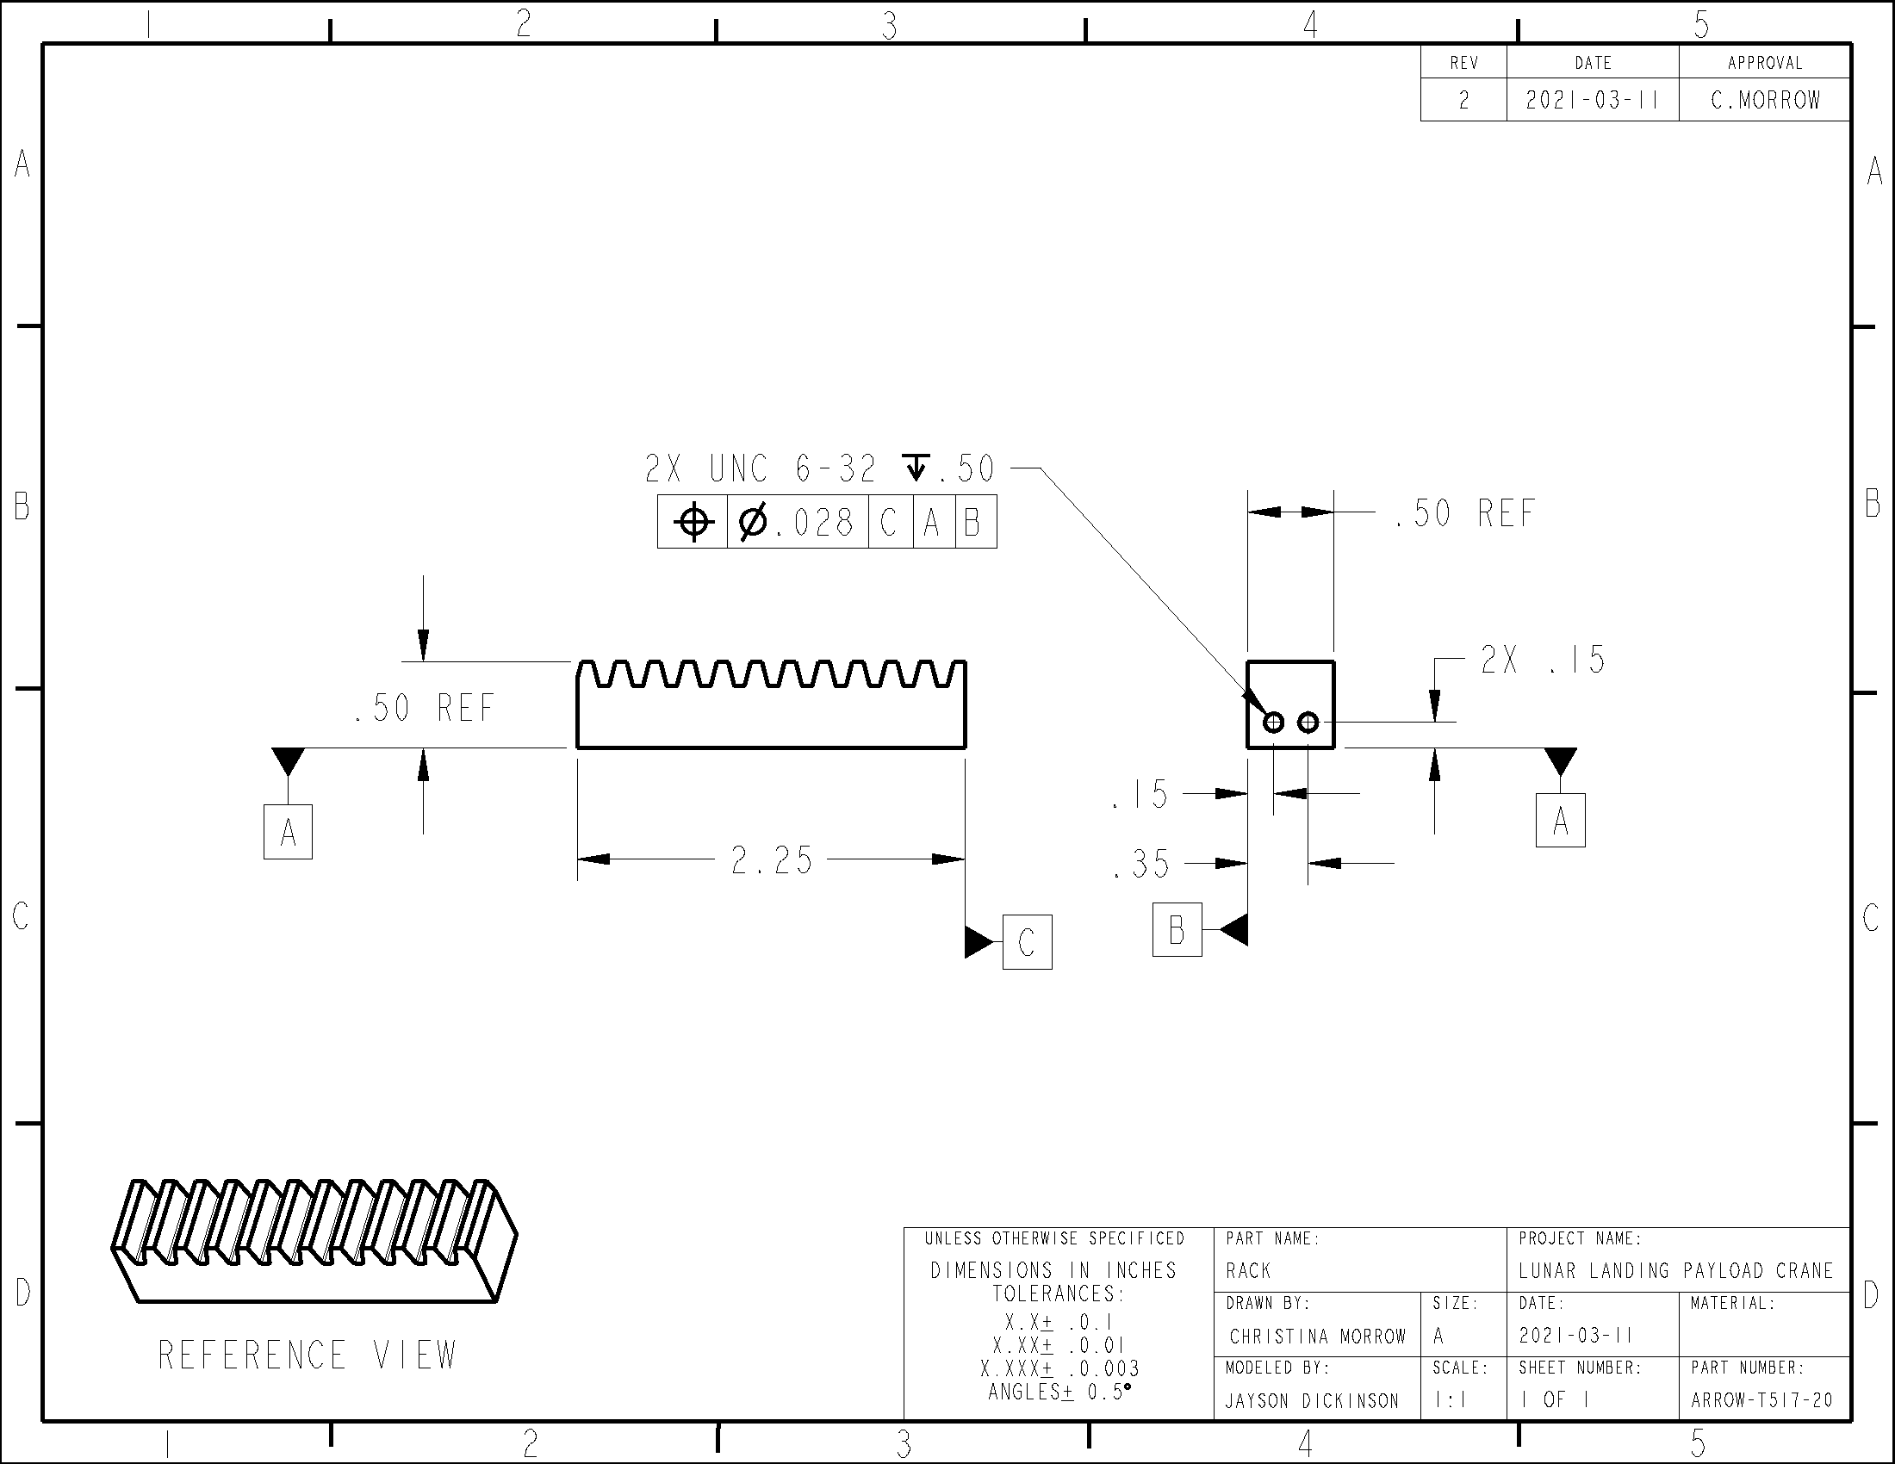

Appendix B-Code
In the following pages, ARROW_Automation.ino is a completely automated code for the ARROW, and ARROW_StepThrough.ino is a demonstration code for operating the ARROW that n is paused between every stage and waits for user input to continue, allowing you to step through the offloading process.
